Chapter 2: Acids and Bases

1. | Which of the following statements is a correct definition for a Brønsted-Lowry acid?
 | A) | Proton acceptor | C) | Electron pair acceptor
 | B) | Electron pair donor | D) | Proton donor

2. | Which of the following statements about a Brønsted-Lowry base is true?
 | A) | The net charge may be zero, positive, or negative.
 | B) | All Brønsted-Lowry bases contain a lone pair of electrons or a π bond.
 | C) | All Brønsted-Lowry bases contain a proton.
 | D) | The net charge may be zero or positive.

3. | Which of the following compounds is both a Brønsted-Lowry acid and base?  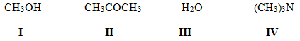
 | A) I, II B) I, III C) II, IV D) I, IV

4. | Which of the following species cannot act as both a Brønsted-Lowry acid and base?
 | A) HCO₃⁻ B) HSO₄⁻ C) HO⁻ D) H₂PO₄⁻

5. | Which of the following species is not a Brønsted-Lowry base?
 | A) BF₃ B) NH₃ C) H₂O D) PO₄³⁻

6. | Which of the following statements about Brønsted-Lowry acids and bases is true?
 | A) | Loss of a proton from a base forms its conjugate acid.
 | B) | Loss of a proton from an acid forms its conjugate base.
 | C) | Gain of a proton by an acid forms its conjugate base.
 | D) | Brønsted-Lowry acid-base reactions always result in the transfer of a proton from a base to an acid.

7. | Which of the following species is the conjugate base of methanol, CH₃OH?
 | A) CH₃OH₂⁺ B) CH₃O⁻ C) CH₃⁻ D) CH₄

8. | Which of the following species is the conjugate base of the hydronium ion, H₃O⁺?
 | A) H₃O B) H₂O⁻ C) H₂O D) HO⁻

9. | Which of the following species is the conjugate acid of ammonia, NH₃?
 | A) H₄N B) H₃N⁺ C) H₂N⁻ D) H₄N⁺

10. | Which is the conjugate acid in the following reaction?  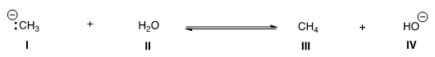
 | A) I B) II C) III D) IV

11. | Which is the conjugate base in the following reaction?  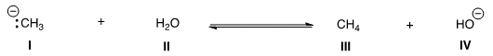
 | A) I B) II C) III D) IV

12. | Which is the conjugate acid in the following reaction?  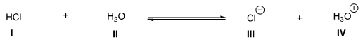
 | A) I B) II C) III D) IV

13. | Which is the conjugate base in the following reaction?  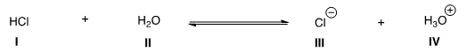
 | A) I B) II C) III D) IV

14. | Which of the following statements about acid strength is true?
 | A) | The stronger the acid, the further the equilibrium lies to the left.
 | B) | The stronger the acid, the smaller the K_{a}.
 | C) | The stronger the acid, the larger the pK_{a}.
 | D) | The stronger the acid, the smaller the pK_{a}.

15. | Which of the following compounds is the strongest acid?  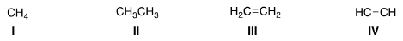
 | A) I B) II C) III D) IV

16. | Which of the following compounds is the strongest acid?
 | A) CH₃OH B) BrCH₂OH C) CH₃NH₂ D) CH₃Cl

17. | Which of the following compounds is the weakest acid?
 | A) HF B) HCl C) HBr D) HI

18. | Which of the following compounds is the weakest acid?
 | A) H₂S B) PH₃ C) HCl D) SiH₄

19. | Which of the following species is the strongest base?
 | A) HO⁻ B) H₂N⁻ C) CH₃COO⁻ D) Cl⁻

20. | Which of the following ranks the compounds in order of increasing basicity, putting the least basic first?
 | A) | CH₃NH₂ < CH₃OH < CH₄ | C) | CH₄ < CH₃NH₂ < CH₃OH
 | B) | CH₃OH < CH₃NH₂ < CH₄ | D) | CH₄ < CH₃OH < CH₃NH₂

21. | Consider the following molecule with protons labeled, I-III. Rank these protons in order of decreasing acidity, putting the most acidic first.  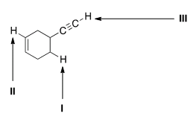
 | A) I > II > III B) I > III > II C) III > II > I D) III > I > II

22. | Rank the following compounds in order of increasing acidity, putting the least acidic first.  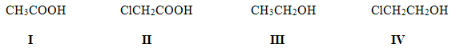
 | A) | III < I < IV < II | C) | II < I < IV < III
 | B) | III < IV < I < II | D) | III < I < II < IV

23. | Rank the following compounds in order of increasing acidity, putting the least acidic first.  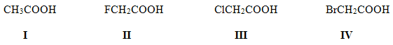
 | A) | I < IV < III < II | C) | II < III < IV < I
 | B) | I < III < IV < II | D) | II < IV < III < I

24. | Rank the following compounds in order of decreasing acidity, putting the most acidic first.  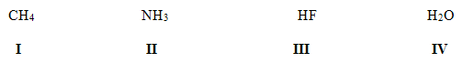
 | A) | IV > II > III > I | C) | I > II > IV > III
 | B) | III > II > IV > I | D) | III > IV > II > I

25. | Rank the following compounds in order of decreasing acidity, putting the most acidic first.  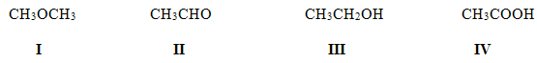
 | A) | IV > II > III > I | C) | III > IV > II > I
 | B) | IV > III > II > I | D) | III > IV > I > II

26. | Rank the following conjugate bases in order of increasing basicity, putting the least basic first.  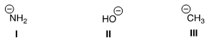
 | A) II < I < III B) II < III < I C) I < II < III D) I < III < II

27. | Rank the following conjugate bases in order of decreasing basicity, putting the most basic first.  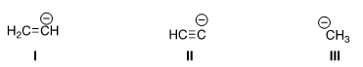
 | A) II > I > III B) I > II > III C) III > I > II D) III > II > I

28. | Which of the following is the strongest base?
 | A) CH₃COCH₃ B) CH₃COOH C) NH₃ D) H₂O

29. | What is the direction of equilibrium when acetylene (C₂H₂) reacts with H₂N⁻ in an acid-base reaction?  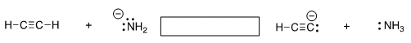
 | A) Left B) Right C) Neither D) Cannot be determined

30. | What is the direction of equilibrium when acetylene (C₂H₂) reacts with ethoxide (CH₃CH₂O⁻) in an acid-base reaction?
 | A) Left B) Right C) Neither D) Cannot be determined

31. | Which of the following statements explain why H₂O is a stronger acid than CH₄?
 | A) | H₂O can form hydrogen bonds while CH₄ cannot.
 | B) | H₂O forms a less stable conjugate base, HO⁻.
 | C) | CH₄ forms a more stable conjugate base, CH₃⁻.
 | D) | H₂O forms a more stable conjugate base, HO⁻.

32. | Which of the following statements explain why HBr is a stronger acid than HF?
 | A) | Br⁻ is more stable than F⁻ because Br⁻ is larger than F⁻.
 | B) | Br⁻ is less stable than F⁻ because Br⁻ is larger than F⁻.
 | C) | Br⁻ is more stable than F⁻ because Br⁻ is less electronegative than F⁻.
 | D) | Br⁻ is less stable than F⁻ because Br⁻ is less electronegative than F⁻.

33. | Which of the following compounds has the lowest pK_{a}?
 | A) H₂O B) H₂S C) NH₃ D) CH₄

34. | Which of the following concepts can be used to explain the difference in acidity between acetic acid (CH₃COOH) and ethanol (CH₃CH₂OH)?
 | A) Hybridization B) Electronegativity C) Resonance D) Size

35. | Which of the following concepts can be used to explain the difference in acidity between acetylene (C₂H₂) and ethylene (C₂H₄)?
 | A) Size B) Resonance C) Inductive effect D) Hybridization

36. | Which of the following concepts can be used to explain the difference in acidity between ethanol (CH₃CH₂OH) and 2-fluoroethanol (FCH₂CH₂OH)?
 | A) Size B) Inductive effect C) Resonance D) Hybridization

37. | Rank the following compounds in order of decreasing acidity, putting the most acidic first.  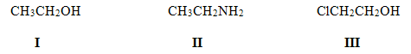
 | A) I > II > III B) III > II > I C) II > III > I D) III > I > II

38. | Which of the following statements about Lewis acids is true?
 | A) | Lewis acids are proton donors.
 | B) | Lewis acids are proton acceptors.
 | C) | Lewis acids are electron pair donors.
 | D) | Lewis acids are electron pair acceptors.

39. | Which of the following statements about Lewis bases is true?
 | A) | Lewis bases are electron pair acceptors.
 | B) | Lewis bases are electron pair donors.
 | C) | Lewis bases are proton donors.
 | D) | Lewis bases are proton acceptors.

40. | Which of the following is a Lewis acid but not a Brønsted-Lowry acid?
 | A) CH₃OH B) H₂O C) CH₃COOH D) BF₃

41. | Which of the following species can be both Lewis acid and Lewis base?  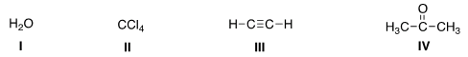
 | A) I, III, IV B) I, II, IV C) II, III, IV D) I, II, III

42. | What is the correct classification of the following compound?  CH₃-O-CH₃
 | A) | Brønsted-Lowry acid and Lewis acid. | C) | Brønsted-Lowry base.
 | B) | Brønsted-Lowry base and Lewis base. | D) | Lewis base.

43. | Identify the Lewis acid in the following reaction.  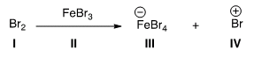
 | A) I B) II C) III D) IV

44. | Identify the Lewis base in the following reaction.  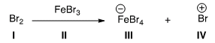
 | A) I B) II C) III D) IV

45. | Which of the following compounds is not a Lewis acid?
 | A) AlCl₃ B) HCl C) H₂O D) CBr₄

46. | What is the role of methylchloride (CH₃Cl) in the following reaction?
 | A) | Lewis acid | C) | Brønsted-Lowry acid
 | B) | Lewis base | D) | Brønsted-Lowry base

47. | What is the electrophilic site in the following compounds?  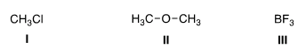
 | A) | I = Carbon; II = carbon; III = boron. | C) | I = Carbon; II = oxygen; III = boron.
 | B) | I = Chlorine; II = carbon; III = boron. | D) | I = Carbon; II = carbon; III = fluorine.

48. | What is the nucleophilic site in the following compounds?  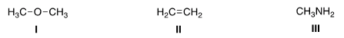
 | A) | I = Hydrogen; II = π electrons in bond; III = nitrogen.
 | B) | I = Oxygen; II = carbon; III = nitrogen.
 | C) | I = Hydrogen; II = carbon; III = carbon.
 | D) | I = Oxygen; II = π electrons in bond; III = nitrogen.

Answer Key

1. | D
2. | B
3. | B
4. | C
5. | A
6. | B
7. | B
8. | C
9. | D
10. | C
11. | D
12. | D
13. | C
14. | D
15. | D
16. | B
17. | A
18. | D
19. | B
20. | D
21. | C
22. | B
23. | A
24. | D
25. | B
26. | A
27. | C
28. | C
29. | B
30. | A
31. | D
32. | A
33. | B
34. | C
35. | D
36. | B
37. | D
38. | D
39. | B
40. | D
41. | A
42. | B
43. | B
44. | A
45. | D
46. | B
47. | A
48. | D

