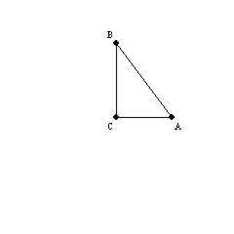

1. Given: In , ;
is a right angle.
Prove: and are complementary.
​
Provide all statements and reasons for this proof.
ANSWER: | Proof:  S1. R1. Given  S2. is a right angle. R2. Given  S3. R3. Definition of right angle  S4. R4. Substitution Prop. of Equality  S5. R5. Subtraction Property of Equality  S6. and are comp. R6. Definition of complementary angles

2. Given:
Prove:
Provide the missing reasons for this proof:
S1. R1.
S2. R2.
S3. R3.
S4. R4.
S5. R5.
ANSWER: | R1. Given  R2. Distributive Law  R3. Substitution Property of Equality  R4. Addition Property of Equality  R5. Division (or Multiplication) Prop. of Eq.

3. Given:
Prove:
Provide the statements for this proof.
S1. R1. Given
S2. R2. Distributive Law (FOIL)
S3. R3. Substitution Proerty of Equality
S4. R4. Addition Property of Equality
ANSWER: | S1.  S2.  S3.  S4.

4. Given:
Prove:
Supply all statements and reasons for the proof.
ANSWER: | Proof:  S1. R1. Given  S2. R2. Subraction Prop. of Equality  S3. R3. Multiplication Property of Equality

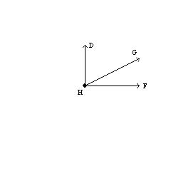

5. Given: is a right angle
Prove: and are complementary
Supply missing statements and missing reasons for this proof.
S1. R1. Given
S2.
R2.
S3. R3. Angle-Addition Postulate
S4.
R4.
S5. R5.
ANSWER: | S1. is a right angle  R2. Definition of right angle  R4. Substitution Property of Equality  S5. and are complementary  R5. Definition of complementary angles

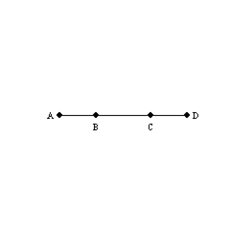

6. Given: A-B-C-D as shown
Prove:
Supply missing statements and missing reasons for this proof:
S1. R1.
S2. R2.
S3. R3. Segment-Addition Postulate
S4. R4. Substitution Property of Equality
ANSWER: | S1. A-B-C-D as shown  R1. Given  R2. Segment-Addition Postulate  S4.

7. Given: is complementary to ;
is complementary to (no drawing provided)
Prove:
​
Supply missing reasons for this proof.
​
S1. is complementary to R1.
S2. is complementary to R2.
S3. R3.
S4. R4.
S5. R5.
S6. R6.
S7, R7.
ANSWER: | R1. Given  R2. Given  R3. Definition of complementary angles  R4. Definition of complementary angles  R5. Substitution Property of Equality  R6. Subtraction Prperty of Equality  R7. Definition of Congruent Angles

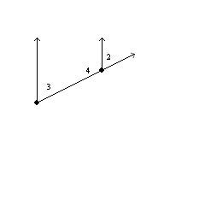

8. Given: and are supplementary
Prove:
Supply missing statements and missing reasons for this proof.
S1. and are supplementary R1.
S2. R2. If the exterior sides of 2 adjacent angles form a
straight line, the angles are supplementary.
S3. R3. Two angles that are supplementray to the same
angle are congruent.
ANSWER: | R1. Given  S2. and are supplementary.  S3.

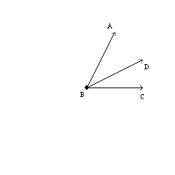

9. Provide missing statements and reasons for the following proof.
Given: bisects
Prove:
S1. R1. Given
S2. R2.
S3. R3. Angle-Addition Postulate
S4. R4.
or
ANSWER: | S1. Given  R2. Definition of angle-bisector  S3.  S4.  R4. Substitution Property of Equality

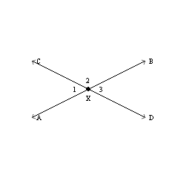

10. Supply missing statements and reasons for the following proof.
Given: and intersect at point X
Prove:
S1. R1.
S2. and are supp. R2.
S3. R3. If the exterior sides of two adjacent angles form a
straight line, these angles are supplementary.
S4. R4. Two angles that are supplementary to the same
angle are congruent.
ANSWER: | S1. and intersect at point X  R1. Given  S3. and are supp.  S4.

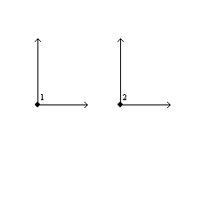

11. Prove: Any two right angles are congruent.
​
Use the following drawing. Provide all statements and reasons.
​
Given: Right angles 1 and 2
Prove:
ANSWER: | S1. Right angles 1 and 2  R1. Given  S2. and  R2. The measure of a right angle is 90.  S3.  R3. Substitution Property of Equality  S4.  R4. Definition of congruent angles.

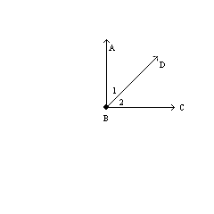

12. Supply all statements and reasons in the following proof.
Given: is a right angle.
Prove: and are complementary.
ANSWER: | S1. is a right angle. R1. Given  S2.  R2. Definition of right angle  S3. R3. Angle-Addition Postulate  S4.  R4. Substitution Property of Equality  S5. and are complementary. R5. Definition of complementary angles.

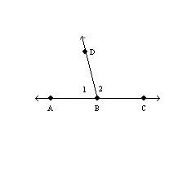

13. In the figure, A-B-C. Explain why and must be supplementary.
ANSWER: | In the figure, is a straight angle. By definition, .  But by the Angle-Addition Postulate.  Then by substitution.  By definition, and are supplementary.

1. Given that D-E-F on , name the property that leads to the conclusion .
ANSWER: | Segment-Addition Postulate

2. Name the property that justifies the following conclusion:
If , then .
ANSWER: | Distributive Property

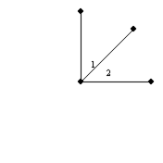

3. In the figure, the exterior sides of the adjacent angles ( and ) form perpendicular rays. How are these angles related?
ANSWER: | They are complementary.

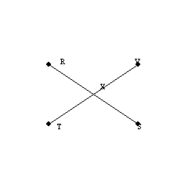

4. If two lines intersect, any two adjacent angles formed are:
ANSWER: | supplementary

5. If two planes intersect, they intersect in a(n):
ANSWER: | line

6. A property of geometry that is accepted as true without proof is a(n):
ANSWER: | postulate

7. The instrument used to construct circles and arcs is the:
ANSWER: | compass

8. Considering the definitions and postulates of geometry, which of the following is a correct statement?
 | a. | An angle has more than one angle-bisector. | b. | A line segment has two midpoints.
 | c. | A line segment has two endpoints. | d. | A plane contains exactly three noncollinear points.

ANSWER: | c

9. Consider a set of lines. Which is a property of the relation “is perpendicular to” for lines?
 | a. | Reflexive | b. | Symmetric
 | c. | Transitive | d. | None of These

ANSWER: | b

10. Which property justifies this conclusion?
If X is a point on and R-X-S, then .
 | a. | Segment-Addition Postulate | b. | Line-Addition Postulate
 | c. | Ruler Postulate | d. | None of These

ANSWER: | a

11. Consider the definition: An isosceles triangle is a triangle that has two congruent sides. Which result must follow from the definition?
 | a. | If is isosceles, then it has two congruent angles.
 | b. | If in , then is an isosceles triangle.
 | c. | If has two congruent sides, then has two congruent angles.
 | d. | None of These

ANSWER: | b

12. In geometry, what is a postulate?
 | a. | statement that defines a term | b. | statement that must be proved
 | c. | a type of geometric figure | d. | None of These

ANSWER: | d

13. For a construction problem, which instrument could you use?
 | a. | calculator | b. | protractor
 | c. | tape measure | d. | compass

ANSWER: | d

14. Which is not a method of reasoning used in geometry?
 | a. | construction | b. | induction
 | c. | intuition | d. | deduction

ANSWER: | a

15. The relation between lines, “is perpendicular to,” has a transitive property.
 | a. | True
 | b. | False

ANSWER: | False

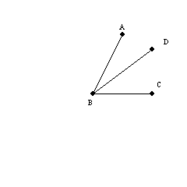

16. According to the Angle-Addition Postulate, m m = m.
 | a. | True
 | b. | False

ANSWER: | True

17. An angle is the union of two rays that have a common endpoint.
 | a. | True
 | b. | False

ANSWER: | True

18. A postulate is accepted without proof while a theorem is a statement that must be proved.
 | a. | True
 | b. | False

ANSWER: | True

19. Points A, B, and C are said to be collinear if they lie on a line.
 | a. | True
 | b. | False

ANSWER: | True

1. Points A, B, and C are collinear on horizontal line segment . Point D lies above . If m is 14° larger than m, find m.
ANSWER: | 83°

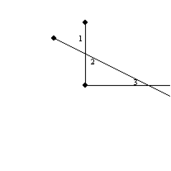

2. In this figure, and are complementary. Also, and are complementary. Regarding and , what conclusion may you draw?
ANSWER: | or m = m

3. Given that and are complementary, what conclusion may you draw?
ANSWER: | m m = 90°

4. If two angles are supplementary and also congruent, then each of these angles is a(n):
ANSWER: | right angle

5. If and are supplementary and , then must be a(n):
ANSWER: | right angle

6. If ray BD bisects , then m
ANSWER: | m

7. If m = x and 90° < x < 180°, then is a(n):
 | a. | acute angle | b. | right angle
 | c. | obtuse angle | d. | straight angle

ANSWER: | c

8. can also be called .
 | a. | True
 | b. | False

ANSWER: | False

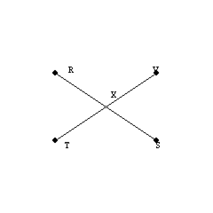

9. In the figure, and are known as vertical angles.
 | a. | True
 | b. | False

ANSWER: | True

10. Where x is the measure of an angle and 0° < x < 90°, the angle is an obtuse angle.
 | a. | True
 | b. | False

ANSWER: | False

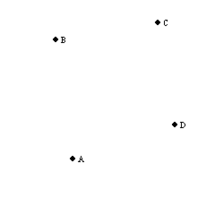

1. Consider the noncollinear points A, B, C, and D. By using two points at a time, find the total number of lines that they determine.
ANSWER: | 6

2. Given that , you can prove that:
 | a. | x = 2 | b. | x = 15
 | c. | x = 16 | d. | None of These

ANSWER: | d

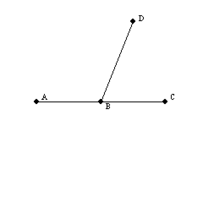

3. Given A-B-C and m while m, it follows that:
 | a. |  | b.
 | c. |  | d. | None of These

ANSWER: | b

4. If M is the midpoint of , then it can be proved that:
 | a. | N is also the midpoint of . | b.
 | c. |  | d. | None of These

ANSWER: | c

5. If two rays are opposite rays, then their union is a straight line.
 | a. | True
 | b. | False

ANSWER: | True

6. If ray BD bisects , then .
 | a. | True
 | b. | False

ANSWER: | True

7. Because it has rained the past 4 days, a person’s intuition can be used to conclude that it will definitely rain again tomorrow.
 | a. | True
 | b. | False

ANSWER: | False

1. and intersect at point E. If is a right angle, what relationship exists between and ?
ANSWER:

2. and are supplementary. is acute. What type of angle is ?
ANSWER: | obtuse

3. The exterior sides of adjacent angles 1 and 2 are perpendicular. If is the bisector of and is the bisector of , find the measure of .
ANSWER: | 45°

1. If and , then:
ANSWER:

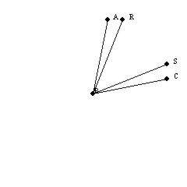

2. If , then it can be proved that:
 | a. |  | b. | is a right angle
 | c. | bisects | d. | None of These

ANSWER: | a

3. Given that , which operation leads to the conclusion that ?
 | a. | adding 3 to each side of the equation | b. | adding -3 to each side of the equation
 | c. | subtracting -3 from each side of the equation | d. | None of These

ANSWER: | b

4. If and are complementary, then each of these angles 1 and 2 is acute.
 | a. | True
 | b. | False

ANSWER: | True

5. With and point G in the interior of , and are complementary.
 | a. | True
 | b. | False

ANSWER: | True

6. When using induction, one draws a conclusion based upon numerous examples or test results.
 | a. | True
 | b. | False

ANSWER: | True

