CASE 1
Tough Mudder Inc.: The Business of Mud Runs
TEACHING NOTE
■ SYNOPSIS ■
Established in 2010 by Harvard MBA graduate, Will Dean, Tough Mudder was market leader in organizing endurance obstacle races (“mud runs”). Dean’s challenge is to extend the popularity of mud runs among a growing range of endurance sports and to reinforce for Tough Mudder initial competitive advantage over its many rivals.
The case explores the formulation and implementation of an entrepreneurial strategy in an emerging industry where there are few barriers to entry. The key issues this case addresses are:
- Where to position a new firm in an emerging industry;
- How to build a sustainable competitive advantage over rivals through exploiting early-mover advantages;
- How to attract and deploy the resources and capabilities needed for the strategy to be effective.

■ TEACHING OBJECTIVES ■
The case is intended as an introductory case in the analysis of firm strategy. The learning outcomes are the development of expertise in:
- The identification and articulation of a company’s strategy
- Understanding the role of strategy in a competitive market
- Positioning a new company’s product in relation both to established substitutes and direct competitors
- Developing strategies to exploit early mover advantages in an industry with few entry barriers
- Choices over acquiring and deploying resources and capabilities in order to implement an entrepreneurial strategy
- Identifying and addressing future competitive threats.
■ POSITION IN THE COURSE ■
Tough Mudder is a small, start-up company with an easily understood product offering. The case is short, and most business students are likely to fall into Tough Mudder’s target customer demographic. Hence, this case is a suitable launch pad for a strategy course.
■ ASSIGNMENT QUESTIONS ■
- What is Tough Mudder’s strategy? In particular, how has Tough Mudder positioned its product in relation to other endurance sports and direct competitors?
- Assess Tough Mudder’s strategy in terms of its fit with its business environment—particularly in relation to its customers’ needs and preferences and its competitors’ offerings and internal resources/capabilities).
- If Tough Mudder is to reinforce its leadership in the mud runs industry, what are the key priorities that Will Dean should attend to?
■ READING ■
R. M. Grant, Contemporary Strategy Analysis (10th edn.), Wiley, 2019, Chapter 1.
■ CASE DISCUSSION AND ANALYSIS ■
What is Tough Mudder’s strategy?
This question typically elicits the story of Tough Mudder’s foundation and development. This provides useful background, but at some point I intervene to ask: “But what is Tough Mudder’s strategy at the time of the case?” (i.e. mid-2018). Here, I encourage the students to describe some of the key attributes of Tough Mudder’s product and the functions which support it (operations, marketing, R&D, etc.). This should elicit some of the following points:
Product Attributes:
• Toughness—endurance run with multiple challenging and fear-inducing obstacles
• Non-competitive: team event; untimed
• Option to by-pass individual obstacles
• Community—pledge, values
Marketing:
• Intensive use of social media
• Emphasis on warrior imagery and military associations (e.g. partnership with Wounded Warrior)
• Customer engagement/market research
Operations:
• Meticulous event planning and operations management to ensure a quality experience
R&D:
• Continual development of new obstacles
Finance:
- Reliance on internal cash flows to fund growth. No venture capital finance. No plans for stock market floatation
Growth strategy
• Rapid domestic and international expansion to pre-empt imitators and establish a standard. Diversification to access additional sources of revenue: franchising its “Boot Camp” fitness centers, seeking a wider TV audience for its events.
Some of the key elements of Tough Mudder’s strategy are evident in the company’s own depiction of its positioning in the market for endurance sports (see Figure 1 of the case reproduced below).
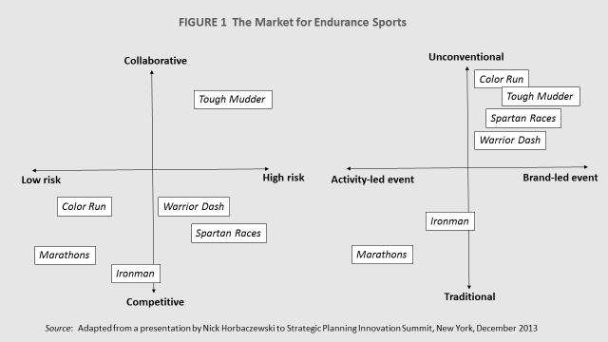
However, the above is only a description of the elements of Tough Mudder’s strategy. The challenge in describing the strategy of any organization is to synthesize the individual components into a coherent statement of the organization’s positioning and direction—what Dick Rumelt calls “a guiding policy.”
At the core of Tough Mudder’s overall strategy is the experience it creates for its participants: its emphasis on challenge, the overcoming of personal limitations, and its values of camaraderie. In positioning itself as the antithesis of modern-day obsessions with comfort, safety, and passive entertainment, it aims to create a social movement based upon tribal notions of social identity.
Assessing Tough Mudder’s Strategy
To explore the logic of Tough Mudder’s strategy, it is important to look at the two key players in Tough Mudder’s external environment: customers and competitors. Inquiring into customer needs and motivation and competition should elicit the factors shown in Figure 2 below.

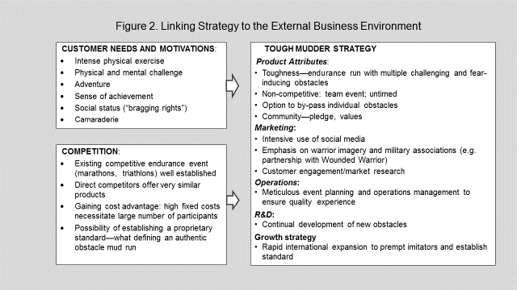
I encourage my students to pay particular attention to the interactions between these different factors and how they have forced Tough Mudder to reconcile conflicting forces.
For example, the critical appeal is the immensity of the challenge and the sense of achievement from overcoming a test of physical and mental stamina—yet, the economics of the business means that Tough Mudder cannot limit its appeal to elite athletes: it must draw several thousand participants to each of its events. By making the event team-based and non-competitive, while permitting the by-passing of obstacles, and encouraging mutual assistance (“No Mudder left behind!”), the events attract a diversity of participants.
The presence of low barriers to entry is a major problem for any company wishing to establish leadership in a new industry. In Tough Mudder’s case, the competition is not just from other commercial enterprises offering events in multiple locations throughout the year, but also from clubs and communities that offer one-off events at low cost. The implications of this mean that Tough Mudder needs to:
- Exploit early-mover advantage by expanding quickly, including entering into foreign markets before local competitors become established
- Place strong emphasis on brand development—ultimately this is aimed at establishing a de facto standard: Tough Mudder defines the few features of an authentic obstacle mud run
- Emphasize quality: in terms of participant experience, Tough Mudder offers the best combination of challenge, engagement, safety, and overall user satisfaction. This requires meticulous attention to course selection and design, operational management, and the gathering of customer feedback for continuous learning and improvement.
Current Challenges and Strategic Priorities
There is no data available on financial performance; however, in terms of revenue growth and market share, it is clear that Tough Mudder has been very successful in the five years since its founding. Sustaining that success requires addressing some key challenges:
- Are mud runs a passing fad? Tough Mudder has done an excellent job of tailoring its product to the needs and desires of its target demographic group and in distinguishing its product from more traditional endurance sports. The ability of mud runs to establish themselves as an endurance sport depends upon participants’ interest in repeating the experience on a regular basis—in the same way that marathon and triathlon participants do. In addition to continually improving the quality of the participant experience, therefore, Tough Mudder also needs to regularly add novelty: launching new and improved obstacles that inspire the imagination of participants.
- Sustaining and reinforcing market leadership. Market leadership is critical to success in this industry because of (a) economies of scale and the preponderance of fixed costs and (b) the importance of brand recognition and standard setting: Tough Mudder as the recognized, authentic mud run.
Ensuring leadership requires that Tough Mudder is an aggressive competitor. This necessitates:
  - maintaining a strong marketing presence with continuing brand advertising and establishing continuing media presence
  - increasing the number of events offered in the US to put pressure on Spartan Races and Warrior Dash
  - being an early mover into new overseas markets to prevent the development of local competitors
  - new product introductions—Tough Mudder can also pressure competitors by imitating their successful new products (e.g. Urban Mudder was a response to Warrior Dash’s Urban Warrior Dash)
  - continual development of obstacles, course planning and overall customer experience in order to maintain a quality differentiation relative to rivals’ offerings.
- Financial sustainability. Sustaining market leadership will require continuing heavy investment. Mud runs are a strong cash-flow business (participants pay in advance) but investing in advertising, obstacle development, customer feedback, and operational improvements is likely to make overall cash flows negative. Important sources of funds are likely to be:
  - Revenue growth through product extensions that broaden participation and offer accessories—race and casual apparel, shoes, phone cases, kids’ clothing, etc.
  - Partnership deals—as Tough Mudder expands its market presence, it has the opportunity to establish new, more lucrative sponsorship deals
  - Equity—given Tough Mudder’s track record of growth, raising additional sums of private equity should not be a problem.
■ KEY TAKE-AWAYS FROM THE CASE DISCUSSION ■

1. Identifying strategy
A firm’s strategy is not a list of all the things a firm is doing, nor is it the story of how it has developed. The key to describing strategy is to synthesize these components into a generalized statement of a company’s relationship with its business environment. The approach outlined in Chapter 1 of Contemporary Strategy Analysis offers a systematic approach to identifying a firm’s strategy (see Figure 3 below). Figure 4 applies the framework of Figure 3 to Tough Mudder—reorganizing and synthesizing the strategy elements described above. This approach suggests that a firm’s strategic positioning can be described by where it is competing and how it is competing. However, the other distinction that Figure 3 makes is between strategy as current positioning and strategy as future direction. Although this distinction is very important for established firms, in the case of a start-up company such as Tough Mudder, the distinction between current and future is less marked —the company is work-in-progress and its current strategy is strongly oriented towards building its competitive position in the future. Hence Figure 4 focuses just on Tough Mudder’s positioning.

2. Assessing the strategy: strategic fit
Chapter 1 of Contemporary Strategy Analysis presents strategy as a link between the firm and its industry environment (see Figure 1.2). The success of a firm’s strategy depends critically upon its fit with the external industry environment and with the internal resources and capabilities of the firm. In the case of a start-up, there are few internal resources and capabilities, hence the focus of the strategy is its external fit in relation to the three primary groups of actors: customers, competitors and suppliers. The Tough Mudder case offers penetrating insights into the challenges of designing strategy to meet the needs and preferences of customers and the threat of competition.
In relation to resources and capabilities, the key issue for a start-up is to quickly acquire and develop the resources and capabilities required by the strategy. Tough Mudder appears to have done an effective job in acquiring the marketing, technical and logistical expertise necessary for the development of its business and creating systems, organizational structure, and corporate culture – through which the people concerned can deploy their expertise.
