Indicate the answer choice that best completes the statement or answers the question.

1. Oil floats on water because oil is ______ than water.
 | a. | heavier
 | b. | less dense
 | c. | lighter
 | d. | denser
 | e. | lower in volume

2. The final digit of a measurement is _____.
 | a. | certain
 | b. | not significant
 | c. | estimated
 | d. | a decimal value
 | e. | not used in calculations

3. In which temperature scale(s) does "zero" (0) mean that all molecular motion has stopped?
 | a. | Kelvin
 | b. | Celsius
 | c. | Fahrenheit
 | d. | Kelvin and Celsius
 | e. | Celsius and Fahrenheit

4. Atoms and molecules in this state of matter are the most highly ordered.
 | a. | solid
 | b. | liquid
 | c. | gas
 | d. | Both a and b are most highly ordered.
 | e. | Both c and c are most highly ordered.

5. The illustration below shows two metal blocks, one hot and one cold, placed together so their sides are touching. How does atomic motion change as time passes?

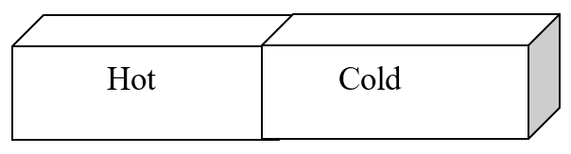
 | a. | Atomic motion does not change as time passes.
 | b. | Atomic motion does change, but it is not predictable how it will change.
 | c. | Atoms in the hot block slow down, and atoms in the cold block speed up.
 | d. | Atoms in the cold block slow down, and atoms in the hot block speed up.
 | e. | Atoms in both the cold and hot block speed up.

6. Below are five descriptions of the kinetic and potential energy of objects. Which is a description of kinetic energy?
​
I. Water moving a waterwheel
II. A skateboarder at the top of a halfpipe
III. The blades of a fan turning
IV. Hot water molecules moving rapidly in a cup of tea
V. A parachutist ready to jump out of a plane
 | a. | I only
 | b. | II and V
 | c. | II, III, and V
 | d. | I, III, and IV
 | e. | All of the above are descriptions of kinetic energy.

7. Tylenol is ordered for a child weighing 42 pounds at a dosage of 15 mg per kilogram of body weight. You need to determine how many milligrams of Tylenol should be administered to this child in a single dose. In order to answer this question, a conversion is used that is written within the body of the question. Which factor is this?
 | a. | 42 pounds = 15 mg of Tylenol
 | b. | 42 pounds = 1 kilogram of body weight
 | c. | 15 mg of Tylenol = 1 kilogram of body weight
 | d. | 15 mg of Tylenol = 1 pound of body weight
 | e. | 1 pound = 1 kilogram of body weight

8. Below are five descriptions of the kinetic and potential energy of objects. Which is a description of potential energy?
​
I. Water moving a waterwheel
II. A skateboarder at the top of a half-pipe
III. The blades of a fan turning
IV. Hot water molecules moving rapidly in a cup of tea
V. A parachutist ready to jump out of a plane
 | a. | I only
 | b. | II and V
 | c. | II, III, and V
 | d. | I, III, and IV
 | e. | All of the above are descriptions of potential energy.

9. How does the kinetic energy of the hot and cold bricks below change as time passes?

 | a. | The kinetic energy of the bricks does not change as time passes.
 | b. | Kinetic energy increases in both blocks.
 | c. | Kinetic energy in the hot block decreases, and kinetic energy in the cold block increases.
 | d. | Kinetic energy in the hot block increases, and kinetic energy in the cold block decreases.
 | e. | Kinetic energy decreases in both blocks.

10. Which of the following statements about significant digits are TRUE?
I. Significant digits are only the digits that are known exactly.
II. Significant digits are all of the digits that are known exactly plus one uncertain digit.
III. Significant digits are a way to communicate the precision of a measurement.
IV. The degree of uncertainty of a measurement is expressed by significant digits.
 | a. | I only
 | b. | II only
 | c. | III and IV only
 | d. | II, III and IV
 | e. | All of the statements are true about significant digits.

11. A juice box is 10.0 cm × 5.5 cm × 4.0 cm. What is the maximum amount of juice that the box can contain?
 | a. | 220 cm³
 | b. | 110 cm³
 | c. | 220 cm²
 | d. | 110 cm²
 | e. | 220 cm

12. The speed of molecules and atoms in this state of matter is the slowest.
 | a. | solid
 | b. | liquid
 | c. | gas
 | d. | Both a and b have the slowest speed.
 | e. | Both b and c have the slowest speed.

13. Tetracycline is a short acting antibiotic. It discolors developing teeth and so is not normally prescribed for children under 8 or pregnant women. An 11-year-old, 84-lb child is prescribed 35 mg/kg tetracycline per day for 10 days. What is the daily dose of tetracycline that should be administered to the child?
 | a. | 5.3 mg
 | b. | 53 mg
 | c. | 1.3 g
 | d. | 1.3 mg
 | e. | 2.9 g

14. Which of the following is MOST likely to be 1.1 m tall?
 | a. | a giraffe
 | b. | a 5-year-old girl
 | c. | a man
 | d. | an infant
 | e. | All four are equally likely to be 1.1 m tall.

15. Convert 312 mg to kilograms.
 | a. | 3.12 × 10^{–4} kg
 | b. | 3.12 kg
 | c. | 0.312 kg
 | d. | 3.12 × 10⁵ kg
 | e. | 3.12 × 10⁸ kg

16. Tylenol is ordered for a child weighing 42 pounds at a dosage of 15 mg per kilogram of body weight. You need to determine how many milligrams of Tylenol should be administered to this child in a single dose. Which of the following units will be in the answer to this question (i.e., is asked for)?
 | a. | pounds of body weight
 | b. | kilograms of body weight
 | c. | milligrams of Tylenol
 | d. | ounces of Tylenol
 | e. | tablets of Tylenol

17. Which of the following unit conversions are useful and correct for converting 312 mg to kilograms?

1 mg = 1,000 g | 1,000 mg = 1 g | 1 kg = 1,000 g | 1,000 kg = 1 g
I | II | III | IV
​
 | a. | I and III
 | b. | II and IV
 | c. | I and IV
 | d. | II and III
 | e. | All of them are useful.

18. Which of the following equalities is NOT correct?
 | a. | 1 cm = 10^{–2} m
 | b. | 10³ g = 1 kg
 | c. | 10^{–3} mL = 1 L
 | d. | 10⁹ nm = 1 m
 | e. | 1 L = 10 dL

19. Which of the following biological molecules are the major nutrients that make up the food that we eat?
I. Proteins
II. Nucleic acids
III. Steroids
IV. Fats
V. Carbohydrates
 | a. | All of these are major nutrients.
 | b. | I, II, IV, and V
 | c. | I and V
 | d. | III, IV, and V
 | e. | I, IV, and V

20. Which of the following equalities is correct?
 | a. | 1 mL = 1 cm³
 | b. | 1 L = 1 cm³
 | c. | 1 mL = 1 cm²
 | d. | 1 L = 1 cm²
 | e. | 1 mL = 1 cm

21. Which of the following describes the kinetic energy of an object or set of objects?
 | a. | water flowing downhill
 | b. | water in a reservoir
 | c. | the forces between two molecules
 | d. | the chemical bonds in a peanut butter and jelly sandwich
 | e. | a book on top of a shelf

22. The number of significant figures in the measurement of 0.004500 cm³ is
 | a. | two.
 | b. | four.
 | c. | five.
 | d. | six.
 | e. | seven.

23. Using significant figures, what is the sum of 12.01 + 1011 + 0.113?
 | a. | 1023.123
 | b. | 1023.12
 | c. | 1023
 | d. | 1020
 | e. | 1000

24. The number of significant figures in the measurement 5.40 × 10⁵ kg is
 | a. | one.
 | b. | two.
 | c. | three.
 | d. | five.
 | e. | eight.

25. A patient weighs 78 kg. What is his weight in pounds?
 | a. | 35 lb
 | b. | 78 lb
 | c. | 80 lb
 | d. | 170 lb
 | e. | 1.7 × 10⁵ lb

26. Tylenol is ordered for a child weighing 42 pounds at a dosage of 15 mg per kilogram of body weight. You need to determine how many milligrams of Tylenol should be administered to this child in a single dose. Which of the following equations is set up to find the answer to this problem?
 | a. | 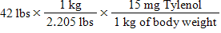
 | b. | 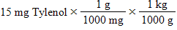
 | c. | 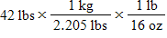
 | d. | 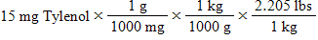
 | e. | 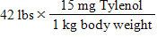

27. Which state of matter has a volume that is constant or fixed?
 | a. | solid
 | b. | liquid
 | c. | gas
 | d. | Both a and b have a constant or fixed volume.
 | e. | Both b and c have a constant or fixed volume.

28. Which of the following is an exact number?
 | a. | the number of milligrams in a gram
 | b. | the number of meters in a kilometer
 | c. | the number of micrometers in a centimeter
 | d. | the number of cubic centimeters in a liter
 | e. | All of the above are exact numbers.

29. The smallest bone on the body, the stirrup-shaped stapes found in the middle ear, has a typical length of less than 0.33 cm. How long in inches is the typical maximum length of the stapes?
 | a. | 7.7 in
 | b. | 1 in
 | c. | 0.84 in
 | d. | 0.8 in
 | e. | 0.13 in

30. Which statement about systems of measurement is TRUE?
 | a. | The English system is the most widely used system of measurement in the world.
 | b. | In science and medicine, the English system is the most common system of measurement.
 | c. | The metric system is used only for scientific measurements.
 | d. | The United States is one of the few countries in which the English system is common.
 | e. | The English system and the metric system measure using the same units.

31. Which of the following is a measured number?
 | a. | the number of eggs in a dozen
 | b. | the number of people in this room
 | c. | the number of milligrams in a gram
 | d. | the number of years in a century
 | e. | the number of grams in one ounce

32. Which of the following biomolecules is NOT correctly matched to one of its roles?
 | a. | glucose; used by cells to perform work
 | b. | fats; source of energy for cells
 | c. | proteins; build cell components
 | d. | glycogen; long-term energy storage
 | e. | carbohydrates; source of glucose

33. The strategy for converting 312 mg to kilograms includes which of the following?
 | a. | Identify the given unit and the asked for unit.
 | b. | Convert the given unit (mg) to the base unit (g) and then to the asked for unit (kg).
 | c. | Write down the conversion factors for the two steps.
 | d. | Arrange the given unit and the conversion factors so units cancel to give the asked for unit.
 | e. | All of the above represent a strategy for converting units.

34. The pediatric dosage of diphenhydramine, an over-the-counter antihistamine, is 1.23 mg/kg of body weight b.i.d. How many milligrams of diphenhydramine should be given to a 66-lb child in one day?
 | a. | 18 mg
 | b. | 1.3 g
 | c. | 37 mg
 | d. | 2.5 g
 | e. | 74 mg

35. Which of the following conversions are needed to convert 36.2 inches to centimeters?
1 inch = 2.54 cm 100 cm = 1 m 2.54 inches = 1 cm 1 cm = 100 m
I II III IV
 | a. | I
 | b. | II
 | c. | III
 | d. | IV
 | e. | I and II

36. A patient's urine has a density of 1.010 g/mL. What is the specific gravity of the patient's urine?
 | a. | 0.9901
 | b. | 1.000
 | c. | 0.1010
 | d. | 1.010
 | e. | 0.99

37. Convert 0.038 L to milliliters.
 | a. | 3.8 mL
 | b. | 38 mL
 | c. | 380 mL
 | d. | 3.8 × 10^{–2} mL
 | e. | 3.8 × 10^{–5} mL

38. Select the choice in which the unit's system and type of measurement is correctly described.
​
 | Unit | System of measurement | Type of measurement
a. | kg | English | mass
b. | qt | English | volume
c. | gal | metric | mass
d. | mi | metric | length
e. | m | English | length
​
 | a. | row a
 | b. | row b
 | c. | row c
 | d. | row d
 | e. | row e

39. Heat is _________ energy, whereas temperature is a _________________.
 | a. | potential; measure of potential energy
 | b. | kinetic; measure of kinetic energy
 | c. | potential; measure of kinetic energy
 | d. | kinetic; measure of potential energy
 | e. | Actually, both heat and temperature are forms of kinetic energy.

40. A child comes into the doctor's office with a temperature of 39.2 °C. What is the child's temperature in Fahrenheit?
 | a. | 103 °F
 | b. | 98.6 °F
 | c. | 277 °F
 | d. | 312 °F
 | e. | 96.8 °F

41. A molecule of hemoglobin is described as being on the _____ scale.
 | a. | macroscopic
 | b. | microscopic
 | c. | atomic
 | d. | both macro- and microscopic
 | e. | both microscopic and atomic

42. Which of the following statements about a "milliliter" is FALSE?
 | a. | It is a prefix followed by a base unit.
 | b. | There are 1,000 milliliters in a liter.
 | c. | The milliliter is a measurement of volume.
 | d. | A milliliter is a measurement in the English system.
 | e. | One milliliter is equal to 1 cc (cm³)

43. The cubic centimeter (cm³ or cc) is the same volume as a
 | a. | centimeter.
 | b. | milliliter.
 | c. | centiliter.
 | d. | deciliter.
 | e. | liter.

44. Which of the following is MOST commonly used to assess the strength of a bone?
 | a. | bone density
 | b. | nutrition and exercise data
 | c. | bone mass
 | d. | blood samples
 | e. | calcium measurement

45. You are asked to administer 3.5 mL of a liquid medication. Which measuring device would be the better choice for measuring 3.5 mL?
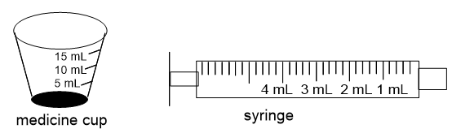
 | a. | The medicine cup is a better choice.
 | b. | The syringe is a better choice.
 | c. | The medicine cup and the syringe are equally good choices.
 | d. | Neither of these measuring devices is precise enough for this measurement.
 | e. | It would depend on the composition of the medication.

46. Room temperature is about 70 °F. What is this temperature in Celsius?
 | a. | 340 °C
 | b. | 294 °C
 | c. | 21 °C
 | d. | 38 °C
 | e. | 6.9 °C

47. Which statement about ruler A and ruler B is correct?
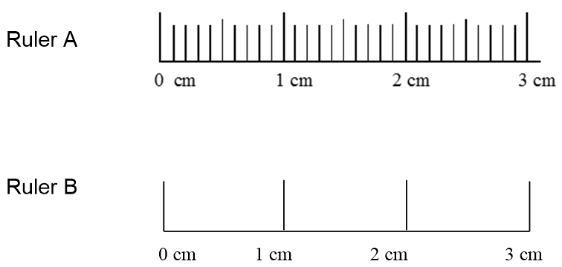
​
 | a. | Measurements made with B are more precise.
 | b. | Measurements made with B should have more significant digits than A.
 | c. | In a measurement made with ruler B, millimeters are estimated
 | d. | Ruler B measurements have three significant digits.
 | e. | In a measurement made with ruler A, no digits are estimated.

48. Which of the following statements about energy is FALSE?
 | a. | Energy is the act of moving an object against an opposing force.
 | b. | An object at rest does not have any potential energy.
 | c. | Energy is the capacity to do work.
 | d. | Temperature is a measure of kinetic energy.
 | e. | Two basic forms of energy are kinetic energy and potential energy.

49. An aluminum ball is dropped into the graduated cylinder containing 90.0 mL of water. If the ball has a volume of 6.8 mL, what is the new volume reading in the graduated cylinder?
 | a. | 6.8 mL
 | b. | 83 mL
 | c. | 90.7 mL
 | d. | 96.8 mL
 | e. | It is not possible to predict the volume without the density of aluminum.

50. A child's height is 36.2 inches. What is his height in centimeters?
 | a. | 91.95 cm
 | b. | 92 cm
 | c. | 91.9 cm
 | d. | 14.25 cm
 | e. | 14.3 cm

51. An ice cube is dropped into a cup of hot tea. How does the kinetic energy of the ice and tea change?
 | a. | The kinetic energy of the ice cube and hot tea does not change.
 | b. | The kinetic energy of the ice and the tea decreases.
 | c. | The kinetic energy of the ice decreases, and the kinetic energy of the tea increases.
 | d. | The kinetic energy of the ice increases, and the kinetic energy of the tea decreases.
 | e. | The kinetic energy of both the ice and the tea increases.

52. Which of the following conversion factors are useful when converting 312 mg to kilograms?
​
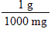 | 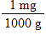 | 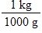 | 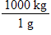
I | II | III | IV
​
 | a. | II and III
 | b. | II and IV
 | c. | I and IV
 | d. | I and III
 | e. | All of them are useful.

53. Which of the following measurements is larger than 1.0 meter?
 | a. | 10 cm
 | b. | 0.0001 km
 | c. | 0.01 km
 | d. | 100 mm
 | e. | 1,000 μm

54. How many milligrams of Tylenol should be administered to this child in a single dose?
 | a. | 14 mg
 | b. | 19 mg
 | c. | 300 mg
 | d. | 290 mg
 | e. | 630 mg

55. There are five different objects with the diameters shown below. Which of these objects is on the atomic scale and cannot be seen with the naked eye?
 | a. | 1.0 nm
 | b. | 1.0 mm
 | c. | 1.0 km
 | d. | 1.0 dm
 | e. | 1.0 cm

56. A child's guardian reports that his child has a fever, with a temperature of 101 °F. What temperature do you expect to measure in °C?
 | a. | 25 °C
 | b. | 38 °C
 | c. | 57 °C
 | d. | 74 °C
 | e. | 126 °C

57. The illustration below shows two metal blocks, one hot and one cold, placed together so their sides are touching. What do you expect to happen to the temperature of the blocks as time passes?

 | a. | Nothing will happen.
 | b. | The temperature of the hot block will decrease, and the temperature of the cold block will increase a little bit, but the hot block will always stay a bit warmer than the cold one.
 | c. | The temperature of the cold block will decrease, and the temperature of the hot block will increase.
 | d. | The hot block will cool down, but the temperature of the cold block will not change.
 | e. | The temperature of the cold block will increase, and the temperature of the hot block will decrease until the temperature of the two blocks is the same.

58. Which of the following is MOST likely to weigh 90 kg?
 | a. | a computer
 | b. | a zebra
 | c. | a man
 | d. | a baby girl
 | e. | All four are equally likely to weigh 90 kg.

59. How many micrometers are there in 52.6 km?
 | a. | 5.26 × 10^{–8} μm
 | b. | 0.0526 μm
 | c. | 5260 μm
 | d. | 5.26 × 10⁹ μm
 | e. | 5.26 × 10¹⁰ μm

60. Using significant figures, what is the product of 0.021 × 0.118 × 1020?
 | a. | 2.52756
 | b. | 2.528
 | c. | 2.53
 | d. | 2.5
 | e. | 3

61. Four students took three measurements each of the distance between the chemistry building and the cafeteria on campus. Each person used a different measuring device and therefore arrived at a different set of measurements. Which person is MOST precise?
​
Student A – counted steps | Student B – measured with a tape measure | Student C – used a radar measuring device | Student D – walked with a measuring wheel
155 m | 157 m | 158 m | 153 m
160 m | 152 m | 152 m | 151 m
180 m | 155 m | 149 m | 153 m
​
 | a. | Student A
 | b. | Student B
 | c. | Student C
 | d. | Student D
 | e. | All are equally precise.

62. Chemistry explains the behavior of matter on the _____ scale(s) so that we can better understand the properties of matter that we observe on the _____ scale(s).
 | a. | microscopic; macroscopic
 | b. | microscopic and macroscopic; atomic
 | c. | macroscopic; microscopic
 | d. | macroscopic; atomic
 | e. | atomic; macroscopic and microscopic

63. When measuring the temperature of gases, Kelvin is often used because it is a function of the kinetic energy of a gas. If a gas is 121 K, what is its temperature in °C?
 | a. | 322 °C
 | b. | –152 °C
 | c. | –242 °C
 | d. | 394 °C
 | e. | 250 °C

64. Every measurement consists of:
 | a. | a number followed by a unit.
 | b. | only whole numbers.
 | c. | a fraction.
 | d. | a number followed by a description of the device used to take the measurement.
 | e. | There are no characteristics that all measurements share.

65. Normal body temperature in Celsius is:
 | a. | 37 °C.
 | b. | 50 °C.
 | c. | 98.6 °C.
 | d. | 212 °C.
 | e. | 288 °C.

66. Which of the following measurements has three significant figures?
 | a. | 0.0058 m
 | b. | 580.0 m
 | c. | 5800 m
 | d. | 0.058 m
 | e. | 0.0580 m

67. This state of matter has the highest kinetic energy.
 | a. | solid
 | b. | liquid
 | c. | gas
 | d. | Both a and b have the highest kinetic energy.
 | e. | Both b and c have the highest kinetic energy.

68. If you dropped a 6.0 g piece of aluminum (density = 2.70 g/mL) into a graduated cylinder containing 93.8 mL of water, what measurement would you read on the graduated cylinder?
 | a. | 92.2 mL
 | b. | 92 mL
 | c. | 96.0 mL
 | d. | 92 μL
 | e. | 96.0 μL

69. Which of the following describes the potential energy of an object or set of objects?
 | a. | water flowing downhill
 | b. | water in a reservoir
 | c. | a person running the 50-yard dash
 | d. | a car speeding up a hill
 | e. | a student pushing open a door

70. This state of matter changes shape depending upon the shape of its container.
 | a. | solid
 | b. | liquid
 | c. | gas
 | d. | Both a and b change shape.
 | e. | Both b and c change shape.

71. A child's height is 36.2 inches, and she wants to know her height in centimeters. In this problem, ______ is the given unit and ______ is the asked for unit.
 | a. | centimeters; inches
 | b. | meters; inches
 | c. | inches; centimeters
 | d. | inches; meters
 | e. | meters; centimeters

72. Which of the following equations is set up to convert 312 mg to kilograms?
 | a. | 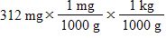
 | b. | 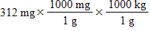
 | c. | 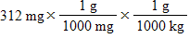
 | d. | 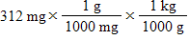
 | e. | 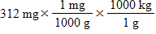

73. Administering the correct dosage of medication to a patient is critical, and the factors below are all key in administering correct dosages. Which factors is focused on in this text chapter?
 | a. | medication
 | b. | patient
 | c. | dosage
 | d. | route
 | e. | time

74. A graduated cylinder contains 20.0 mL of water. A pebble is submerged in the water, causing the volume of the water in the graduated cylinder to increase to 24.3 mL. What is the volume of the pebble?
 | a. | 48.3 mL
 | b. | 24.3 mL
 | c. | 20.0 mL
 | d. | 8.6 mL
 | e. | 4.3 mL

75. Which of the following measurements includes a base unit?
 | a. | 298 mg
 | b. | 2.981 g
 | c. | 5 × 10³ kg
 | d. | 3.6 mL
 | e. | 168 mm

76. The following illustrates the digital readout of two different balances. Which of the following statements about the two measurements is NOT correct?
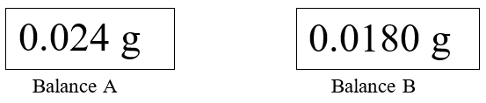
 | a. | Balance B is more precise than balance A.
 | b. | Balance A shows a measurement with two significant figures.
 | c. | For both balances A and B, the last digit may fluctuate slightly when measuring.
 | d. | The measurement shown on balance A can also be stated as 24 mg.
 | e. | Balance B and balance A show measurements with the same number of significant digits.

77. Tylenol is ordered for a child weighing 42 pounds at a dosage of 15 mg per kilogram of body weight. You need to determine how many milligrams of Tylenol should be administered to this child in a single dose. In order to answer this question, it is also necessary to use a conversion factor that must be looked up in a table (or have memorized). Which conversion factor is this?
​
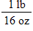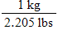
I II III IV
 | a. | I
 | b. | II
 | c. | III
 | d. | IV
 | e. | Both III and IV are correct.

78. A graduated cylinder contains water with some food coloring in it. What is measured by the graduated cylinder?
 | a. | volume
 | b. | weight
 | c. | distance
 | d. | length
 | e. | temperature

79. A patient has a kidney infection. Which of the following is MOST likely to be the specific gravity of the patient's urine?
 | a. | 1.010
 | b. | 1.005
 | c. | 1.002
 | d. | 1.025
 | e. | 1.040

80. Which conversion factor is required to convert 36.2 inches to centimeters?
​
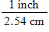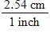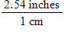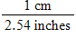
I II III IV
 | a. | I
 | b. | II
 | c. | III
 | d. | IV
 | e. | None of the conversion factors is required.

81. Which temperature scale(s) is/are relative (i.e., based on the freezing and boiling point of water)?
 | a. | Kelvin
 | b. | Celsius
 | c. | Fahrenheit
 | d. | Kelvin and Celsius
 | e. | Celsius and Fahrenheit

82. A person with a T-score of less than –2.5 has a bone mineral density that ______ normal and is said to have ______.
 | a. | is; normal bone density
 | b. | is less than; normal bone density
 | c. | is less than; osteoporosis
 | d. | is greater than; osteopenia
 | e. | is; osteopenia

83. Which of the following is likely to be shorter than 1 m?
 | a. | the length of a car
 | b. | the height of an average adult
 | c. | the width of a computer screen
 | d. | the height of a one-story building
 | e. | the length of an adult giraffe's neck

84. Identify whether the following represent the microscopic, macroscopic, or atomic scale.
​
i. Hemoglobin ii. Person iii. Red blood cell

 | a. | i. atomic ii. microscopic iii. macroscopic
 | b. | i. atomic ii. macroscopic iii. microscopic
 | c. | i. microscopic ii. atomic iii. macroscopic
 | d. | i. microscopic ii. macroscopic iii. atomic
 | e. | i. macroscopic ii. atomic iii. microscopic

85. Which of the following is an exact number?
 | a. | the number of people in this room
 | b. | the mass of a penny
 | c. | the distance a runner runs in a 5 K race
 | d. | the volume of milk in a gallon
 | e. | the mass of cereal in a 1 lb box

86. What is the density of a substance with a mass of 10.6 g and a volume of 12.0 mL?
 | a. | 0.883 g/mL
 | b. | 1.4 g/mL
 | c. | 22.6 g/mL
 | d. | 1.13 mL/g
 | e. | 127 gmL

87. What is measured by ruler A?
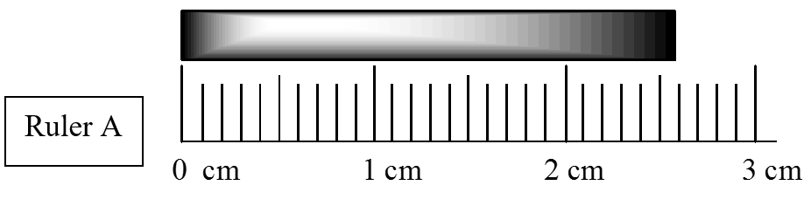
 | a. | volume
 | b. | weight
 | c. | grams
 | d. | length
 | e. | temperature

88. A patient's fluid intake is monitored over a 6-hour period. If the patient drinks 232.0 mL, 300. mL, and 41 mL of water, what is the total volume of the fluid intake?
 | a. | 573.0 mL
 | b. | 573 mL
 | c. | 570 mL
 | d. | 600 mL
 | e. | 57 mL

89. Label each box with the appropriate state of matter.

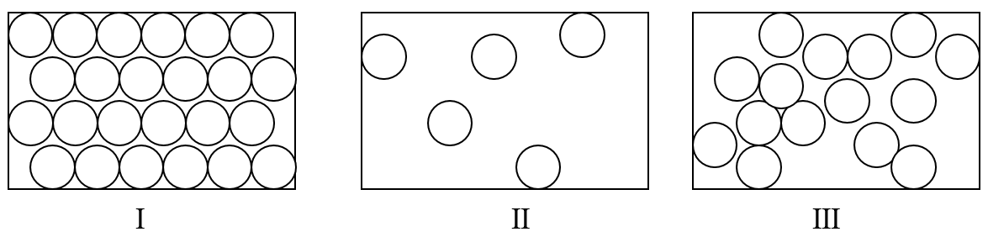
 | a. | I: gas II: liquid III: solid
 | b. | I: liquid II: solid III: gas
 | c. | I: solid II: liquid III: gas
 | d. | I: gas II: solid III: liquid
 | e. | I: solid II: gas III: liquid

90. How many nanometers are in a meter?
 | a. | 1 × 10^{–9}
 | b. | 1 × 10⁹
 | c. | 1 × 10^{–12}
 | d. | 1 × 10³
 | e. | 1 × 10^{–6}

91. A patient is given 5.00 mL of a medication that contains 0.0012 g of active ingredient per mL. To determine the amount of active ingredient administered, the product of the two numbers is calculated (5.00 mL × 0.0012 g/mL). Using significant figures, what is this product?
 | a. | 0.006 g
 | b. | 0.0060 g
 | c. | 0.00600 g
 | d. | 6.00 g
 | e. | 0 g

92. How long is the bar above the ruler?
 | a. | 2.5 cm
 | b. | 2.6 cm
 | c. | 2.59 cm
 | d. | 3 cm
 | e. | 2 cm

93. Which of the following is a consequence of starvation?
 | a. | Protein is metabolized.
 | b. | Heart muscle can be metabolized.
 | c. | Insufficient glucose is available for brain function.
 | d. | Fat loss occurs.
 | e. | All of the above are a consequence of starvation.

94. Measurements taken with ruler A and ruler B differ slightly. In what way do the measurements differ?
 | a. | A measurement taken with ruler A has two more significant digits than ruler B.
 | b. | A measurement taken with ruler B has two more significant digits than ruler A.
 | c. | A measurement taken with ruler A has one more significant digit than ruler B.
 | d. | A measurement taken with ruler B has one more significant digit than ruler A.
 | e. | In fact, measurements taken with ruler A and B are the same.

95. Which of the following measurements represents the LEAST mass?
 | a. | 0.1 mg
 | b. | 1000 μg
 | c. | 0.001 g
 | d. | 1 cg
 | e. | 0.010 kg

96. Water has a density of 1.0 g/mL. What is the mass of 25 mL of water?
 | a. | 0.25 g
 | b. | 2.5 g
 | c. | 25 g
 | d. | 250 g
 | e. | 25 kg

Answer Key
1. b

2. c

3. a

4. a

5. c

6. d

7. c

8. b

9. c

10. d

11. a

12. a

13. c

14. b

15. a

16. c

17. d

18. c

19. e

20. a

21. a

22. b

23. c

24. c

25. d

26. a

27. d

28. e

29. e

30. d

31. e

32. d

33. d

34. a

35. a

36. d

37. b

38. b

39. b

40. a

41. c

42. d

43. b

44. a

45. b

46. c

47. c

48. b

49. d

50. c

51. d

52. d

53. c

54. d

55. a

56. b

57. e

58. c

59. e

60. d

61. d

62. e

63. b

64. a

65. a

66. e

67. c

68. c

69. b

70. e

71. c

72. d

73. c

74. e

75. b

76. e

77. c

78. a

79. e

80. b

81. e

82. c

83. c

84. b

85. a

86. a

87. d

88. b

89. e

90. b

91. b

92. c

93. e

94. c

95. a

96. c

