Student name:__________
MULTIPLE CHOICE - Choose the one alternative that best completes the statement or answers the question.
1) What is the ground-state electronic configuration of a carbon atom?

A) 1s ², 2s ², 2p ⁵
B) 1s ², 2s ², 2p ²
C) 1s², 2s², 2p⁶
D) 1s², 2s², 2p⁴

2) What is the ground-state electronic configuration of a fluorine atom?

A) 1s², 2s², 2p²
B) 1s², 2s², 2p³
C) 1s², 2s², 2p⁴
D) 1s2, 2s2, 2p5

3) What is the ground-state electronic configuration of a magnesium cation (Mg²⁺)?

A) 1s², 2s², 2p⁶
B) 1s2, 2s2, 2p6, 3s1
C) 1s², 2s², 2p⁶, 3s²
D) 1s², 2s², 2p⁶, 3s², 3p²

4) What is the ground-state electronic configuration of a chlorine anion (Cl⁻)?

A) 1s², 2s², 2p⁶
B) 1s², 2s², 2p⁶, 3s², 3p⁶
C) 1s², 2s², 2p⁶, 3s², 3p⁵
D) 1s², 2s², 2p⁶, 3s², 3p⁴

5) Which of the following statements about valence electrons is true?

A) They are the most tightly held electrons.
B) They do not participate in chemical reactions.
C) They are the outermost electrons.
D) They reveal the period number of a second-row element.

6) Which of the following atoms will have a full 3s orbital in the ground state?

A) Hydrogen
B) Lithium
C) Potassium
D) Rubidium

7) Which of the following statements about bonding is true?

A) Covalent bonds result from the transfer of electrons from one element to another.
B) Ionic bonds result from the transfer of electrons from a metal to a non-metal.
C) Ionic bonds result from the sharing of electrons between two non-metals.
D) Covalent bonds result from the sharing of electrons between two metals.

8) Which of the following would you expect to have ionic bonds?

A) CO
B) FBr
C) NF₃
D) NaCl

9) Which of the following molecules has nonpolar covalent bonds?

A) HCl
B) N₂
C) CHCl ₃
D) NO

10) Which of the following molecules contain both covalent and ionic bonds?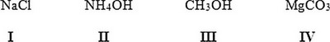

A) I, II
B) I, IV
C) II, III
D) II, IV

11) Which of the following would most likely form an ionic bond?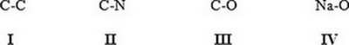

A) I
B) II
C) III
D) IV

12) Which of the following statements correctly describes the typical number of bonds for carbon, nitrogen, and oxygen in most neutral organic molecules?

A) Carbon forms 4 covalent bonds, nitrogen forms 2 covalent bonds, and oxygen forms 3 covalent bonds.
B) Carbon forms 4 covalent bonds, nitrogen forms 3 covalent bonds, and oxygen forms 2 covalent bonds.
C) Carbon forms 4 covalent bonds, nitrogen forms 5 covalent bonds, and oxygen forms 2 covalent bonds.
D) Carbon forms 4 covalent bonds, nitrogen forms 5 covalent bonds, and oxygen forms 4 covalent bonds.

13) Which is not an acceptable Lewis structure for the anion CH2NCO−?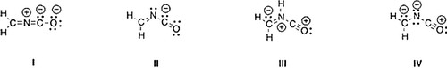

A) I
B) II
C) III
D) IV

14) Which of the following Lewis structures is correct?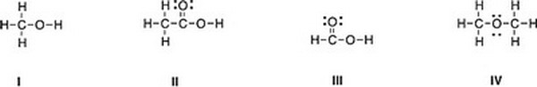

A) I
B) II
C) III
D) IV

15) Which of the following Lewis structures is correct?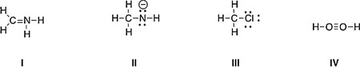

A) I, II
B) I, III
C) II, III
D) III, IV

16) Which is the correct Lewis structure for acetic acid (CH3CO2H)?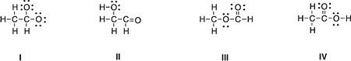

A) I
B) II
C) III
D) IV

17) In which of the following ions does carbon have a formal charge?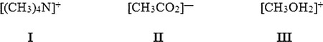

A) I
B) II
C) III
D) None of these

18) In which of the following ions does carbon have a formal charge?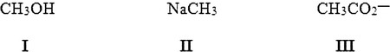

A) I
B) II
C) III
D) None of these

19) What is the formal charge of carbon in carbon monoxide (CO) when drawn with a triple bond?

A) 0
B) −2
C) −1
D) +1

20) What is the formal charge of the carbon in carbon dioxide (CO2) when drawn with two double bonds?

A) +1
B) 0
C) −1
D) −2

21) Which of the following statements about constitutional isomers is true?

A) Constitutional isomers are different molecules having the different molecular formula.
B) Constitutional isomers are different molecules having the same molecular formula.
C) Constitutional isomers are same molecules having the different molecular formula.
D) Constitutional isomers are same molecules having the same molecular formula.

22) How many constitutional isomers are there for a molecule having the molecular formula C2H6O?

A) 1
B) 2
C) 3
D) 4

23) How many constitutional isomers are there for a molecule having the molecular formula C3H8O?

A) 1
B) 2
C) 3
D) 4

24) How many constitutional isomers are there for a molecule having the molecular formula C3H6?

A) 1
B) 2
C) 3
D) 4

25) How many constitutional isomers are there for a molecule having the molecular formula C2H4Cl2?

A) 1
B) 2
C) 3
D) 4

26) How many different isomers are there for a compound having the molecular formula C3H6O?

A) 4
B) 5
C) 6
D) 7

27) Which of the following molecules are constitutional isomers?

A) I, II, IV
B) II, III, IV
C) I, III, IV
D) I, II, III

28) Which of the following compounds has an atom with an unfilled valence shell of electrons?

A) H2O
B) BCl3
C) CH 4
D) CO2

29) Which of the following compounds has an atom with more than eight valence electrons?

A) H2CO3
B) H2SO4
C) H 2O
D) HBr

30) How many electrons are around phosphorus in phosphoric acid (H3PO4)?

A) 6
B) 8
C) 10
D) 12

31) Which of the following statements about resonance structures is true?

A) Resonance structures have the same placement of electrons but different arrangement of atoms.
B) Resonance structures have the same placement of atoms but different arrangement of electrons.
C) Resonance structures have the same placement of atoms and the same arrangement of electrons.
D) Resonance structures have different placement of atoms and different arrangement of electrons.

32) Which of the following statements about resonance structures is not true?

A) There is no movement of electrons from one form to another.
B) Resonance structures are not isomers.
C) Resonance structures differ only in the arrangement of electrons.
D) Resonance structures are in equilibrium with each other.

33) Which of the following pair does not represent resonance structures?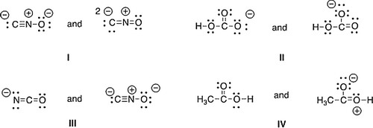

A) I
B) II
C) III
D) IV

34) What 2 things will change between two resonance structures?

A) The position of multiple bonds and non-bonded electrons.
B) The position of multiple bonds and single bonds.
C) The placement of atoms and single bonds.
D) The placement of atoms and non-bonded electrons.

35) Which of the following is a resonance structure of the compound below?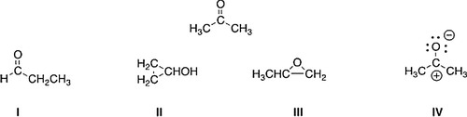

A) I
B) II
C) III
D) IV

36) Which of the following resonance structures is the least important contributor to the resonance hybrid of the formate anion, HCOO−?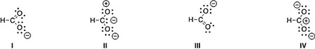

A) I
B) II
C) III
D) IV

37) Rank the following in order of decreasing importance as contributing structures to the resonance hybrid of formaldehyde, H2CO.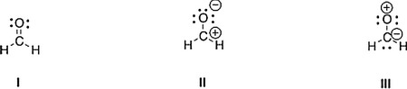

A) I > II > III
B) I > III > II
C) II > I > III
D) III > II > I

38) Follow the curved arrows to draw the second resonance structure for the ion below.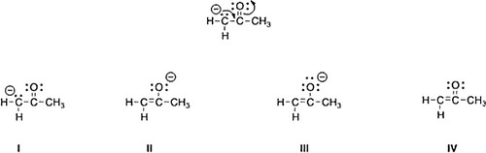

A) I
B) II
C) III
D) IV

39) Which is more important in each pair of contributing resonance structures?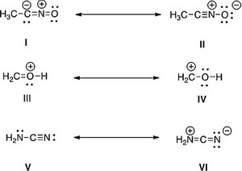

A) II, IV, V
B) II, III, V
C) II, III, VI
D) I, IV, V

40) What is the approximate value of the H-C-H bond angle in methane, CH4?

A) 90°
B) 109.5°
C) 120°
D) 180°

41) What is the approximate C-C-C bond angle in propene, CH3CH = CH2?

A) 90°
B) 109.5°
C) 120°
D) 180°

42) What is the approximate H-C-O bond angle in formaldehyde, H2CO?

A) 90°
B) 109.5°
C) 120°
D) 180°

43) Determine the geometry around the indicated atom in each species.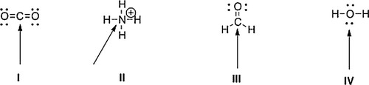

A) I = Linear; II = tetrahedral; III = trigonal planar; IV = tetrahedral
B) I = Linear; II = tetrahedral; III = trigonal planar; IV = linear
C) I = Trigonal planar; II = linear; III = tetrahedral; IV = trigonal planar
D) I = Tetrahedral; II = trigonal planar; III = linear; IV = tetrahedral

44) What is the approximate bond angle for the C-C-N bond in acetonitrile, CH3CN?

A) 90°
B) 109.5°
C) 120°
D) 180°

45) What is the molecular geometry around the boron atom in BH3?

A) Tetrahedral
B) Trigonal Planar
C) Trigonal Pyramidal
D) Linear

46) What is the molecular geometry around the carbon atom in CH4?

A) Tetrahedral
B) Trigonal Planar
C) Trigonal Pyramidal
D) Linear

47) Which of the following is the appropriate conversion of the condensed structure, CH3COCH3, to a Lewis structure?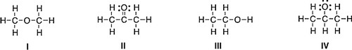

A) I
B) II
C) III
D) IV

48) Which of the following is the appropriate conversion of (CH3)2CHCH2CHClCH3to a skeletal structure?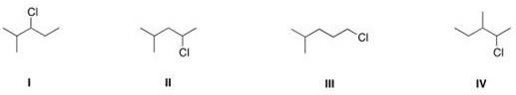

A) I
B) II
C) III
D) IV

49) Which of the following is the appropriate conversion of (CH3)4C to a skeletal structure?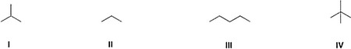

A) I
B) II
C) III
D) IV

50) What is the condensed formula of the compound below?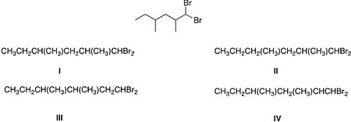

A) I
B) II
C) III
D) IV

51) Which of the following is the appropriate conversion of (CH3)2CHOCH2CH2CH2OH to a skeletal structure?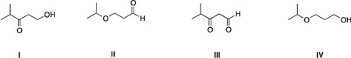

A) I
B) II
C) III
D) IV

52) Convert the following skeletal structure to a condensed structure.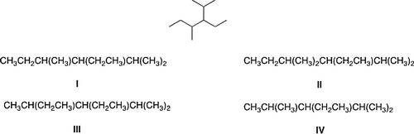

A) I
B) II
C) III
D) IV

53) Avobenzone is an active ingredient in some common sunscreens. Which of the following is the correct molecular formula for avobenzone?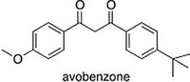

A) C22O22O3
B) C20H22O3
C) C21H23O3
D) C20H24O3

54) In which structure is the hybridization incorrect?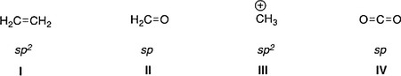

A) I
B) II
C) III
D) IV

55) What is the hybridization for each of the indicated atoms in the following compound?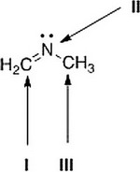

A) I = sp2; II = sp2; III = sp2.
B) I = sp2; II = sp3; III = sp3.
C) I = sp; II = sp2; III = sp3.
D) I = sp2; II = sp2; III = sp3.

56) What is the hybridization of the carbon atom in the methyl cation, (CH3+)?

A) sp3
B) sp2
C) sp
D) p

57) What is the hybridization of the nitrogen atom in the ammonium cation, NH4+?

A) sp3
B) sp2
C) sp
D) p

58) Which atomic orbitals overlap to form the C-H s bonding molecular orbitals of ethane, CH3CH3?

A) Csp2+ H1s
B) Csp3+ H1s
C) C2p + H1s
D) Csp + H1s

59) Which atomic orbitals overlap to form the C-H s bonding molecular orbitals of ethylene, H2C=CH2?

A) C2p + H1s
B) Csp + H1s
C) Csp3+ H1s
D) Csp2+ H1s

60) Which atomic orbitals overlap to form the carbon-carbon s and p bonding molecular orbitals of ethylene, H2C=CH2?

A) Csp3+ Csp3, and C2p + C2p
B) Csp3+ Csp3, and Csp2+ Csp2
C) Csp2+ Csp2, and C2p + C2p
D) Csp2+ Csp2, and Csp2+ Csp2

61) Which atomic orbitals overlap to form the C-H s bonding molecular orbitals of acetylene, C2H2?

A) Csp + H1s
B) C2p +H1s
C) Csp3+ H1s
D) Csp2+ H1s

62) Which atomic orbitals overlap to form the carbon-carbon s bonding molecular orbital of acetylene, C2H2?

A) Csp2+ Csp2
B) Csp + Csp
C) Csp3+ Csp3
D) C2p + C2p

63) When forming molecular orbitals from atomic orbitals, what is the order of increasing C-H bond strength for the following set?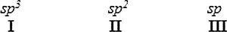

A) II < I < III
B) III < I < II
C) III < II < I
D) I < II < III

64) What is the order of decreasing bond length for a C-C bond composed of the following molecular orbitals?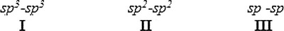

A) I > III > II
B) I > II > III
C) III > II > I
D) II > III > I

65) Which of the following statements about electronegativity and the periodic table is true?

A) Electronegativity decreases across a row of the periodic table.
B) Electronegativity increases down a column of the periodic table.
C) Electronegativity increases across a row of the periodic table.
D) Electronegativity does not change down a column of the periodic table.

66) Rank the following atoms in order of increasing electronegativity, putting the least electronegative first.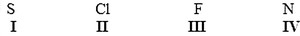

A) I < II < III < IV
B) I < IV < II < III
C) III < II < IV < I
D) I < II < IV < III

67) Rank the following atoms in order of decreasing electronegativity, putting the most electronegative first.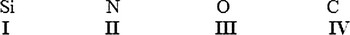

A) I > IV > II > III
B) II > III > IV > I
C) III > IV > II > I
D) III > II > IV > I

68) Which molecule has the greatest difference in electronegativity (DE) between the two different elements?

A) CO2
B) H2S
C) NH3
D) H2O

69) Which compound contains the most polar bond?

A) I
B) II
C) III
D) IV

70) Which of the following compounds are non-polar?

A) I, IV
B) I, II
C) II, III
D) II, IV

71) Which of the following molecules has non-polar covalent bonds?

A) CO2
B) N2
C) CCl4
D) HF

72) Which of the following molecules has polar covalent bonds?

A) MgO
B) NH3
C) Cl2
D) NaBr

73) Which of the following covalent bonds has the largest dipole moment?

A) C-H
B) C-C
C) C-O
D) H-F

74) Which of the following molecules has the smallest dipole moment?

A) CO2
B) HCl
C) H2O
D) NH3

75) Which of the following molecules does not have a net dipole moment of zero?

A) CCl4
B) BF3
C) CO2
D) NH3

76) Which of the following molecules has a net dipole moment of zero?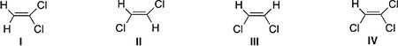

A) I
B) II
C) III
D) IV

77) Consider compounds which contain both a heteroatom and a double bond. For which compound is no additional Lewis structure possible?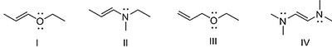

A) I
B) II
C) III
D) IV

78) Which of the following molecules has a net dipole moment of zero?

A) CH₄
B) CO ₂
C) BH₃
D) All of these are correct.

Answer Key
Test name: Topics 1

1) B

2) D

3) A

4) B

5) C

6) D

7) B

8) D

9) B

10) D

11) D

12) B

13) C

14) D

15) C

16) D

17) D

18) B

19) C

20) B

21) B

22) B

23) C

24) B

25) B

26) D

27) D

28) B

29) B

30) C

31) B

32) D

33) C

34) A

35) D

36) B

37) A

38) C

39) B

40) B

41) C

42) C

43) A

44) D

45) B

46) A

47) B

48) B

49) D

50) A

51) D

52) A

53) B

54) B

55) D

56) B

57) A

58) B

59) D

60) C

61) A

62) B

63) D

64) B

65) C

66) B

67) D

68) D

69) B

70) A

71) B

72) B

73) D

74) A

75) D

76) B

77) C

78) D

