Anatomy and Physiology, 5e (Marieb/Mitchell/Smith)
Chapter 1 The Human Body: An Orientation

1.1 Matching Questions

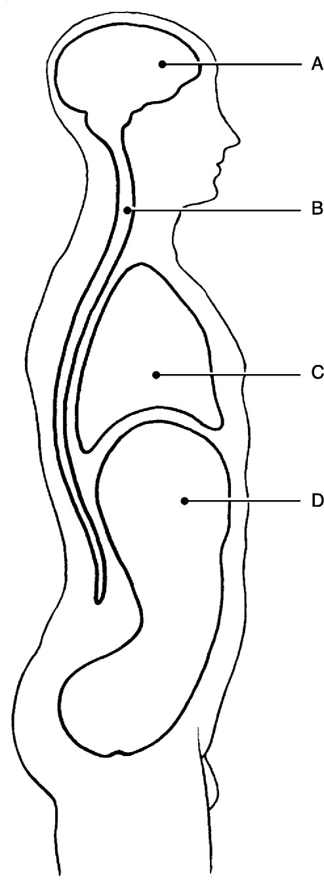

Figure 1.1

Using Figure 1.1, match the following cavities:

1) Thoracic cavity.
Answer: C
Diff: 1 Page Ref: 15-16; Fig. 1.9

2) Cranial cavity.
Answer: A
Diff: 1 Page Ref: 15-16; Fig. 1.9

3) Abdominal cavity.
Answer: D
Diff: 1 Page Ref: 15-16; Fig. 1.9
4) Vertebral cavity.
Answer: B
Diff: 1 Page Ref: 15-16; Fig. 1.9

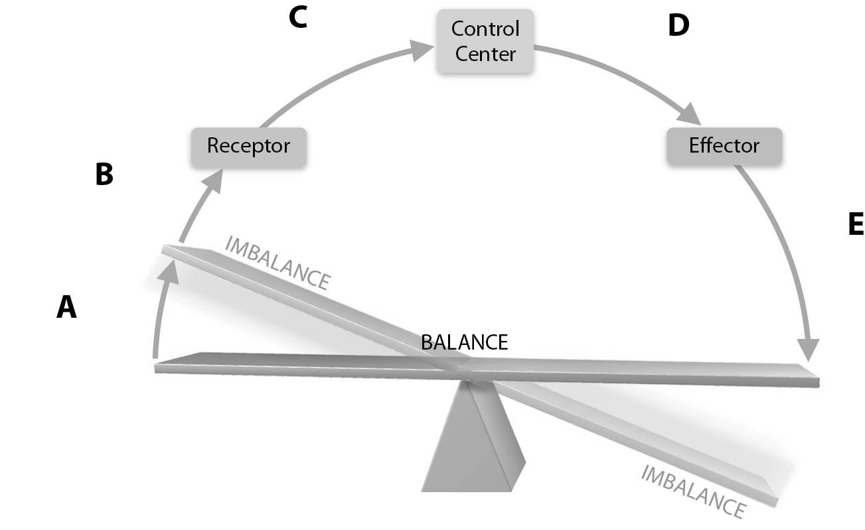

Figure 1.2

Using Figure 1.2, match the following regions:

5) Input.
Answer: C
Diff: 2 Page Ref: 9; Fig. 1.4

6) Receptor.
Answer: B
Diff: 2 Page Ref: 9; Fig. 1.4

7) Output.
Answer: D
Diff: 2 Page Ref: 9; Fig. 1.4

8) Stimulus.
Answer: A
Diff: 2 Page Ref: 9; Fig. 1.4

9) Response.
Answer: E
Diff: 2 Page Ref: 9; Fig. 1.4
Match the following systems to their functions:

A) Integumentary
B) Muscular
C) Skeletal
D) Nervous

10) Directly causes mechanical motion.
Diff: 1 Page Ref: 6; Fig. 1.3c

11) Responds to environmental changes by transmitting electrical impulses.
Diff: 1 Page Ref: 6; Fig. 1.3d

12) Provides support and levers for muscles to pull
Diff: 1 Page Ref: 6; Fig. 1.3b

13) Protects underlying organs from environmental damage and synthesizes vitamin D.
Diff: 2 Page Ref: 6; Fig. 1.3a

Answers: 10) B 11) D 12) C 13) A

Match the following systems to their functions:

A) Cardiovascular
B) Immune
C) Lymphatic
D) Endocrine

14) Controls the body with chemical molecules called hormones.
Diff: 2 Page Ref: 6; Fig. 1.3e

15) Delivers oxygen and nutrients to the tissues.
Diff: 1 Page Ref: 6; Fig. 1.3f

16) Produces antibodies that attach to foreign substances.
Diff: 1 Page Ref: 7; Fig. 1.3g

17) Removes and filters excess fluid from tissues.
Diff: 1 Page Ref: 7; Fig. 1.3g

Answers: 14) D 15) A 16) B 17) C
Match the following examples of feedback mechanisms:

A) Positive feedback
B) Negative feedback

18) Used for changes in blood glucose levels
Diff: 2 Page Ref: 9

19) Used for changes in blood pressure
Diff: 3 Page Ref: 9

20) Used for blood clotting
Diff: 2 Page Ref: 9-10

21) Used for childbirth
Diff: 2 Page Ref: 9-10

Answers: 18) B 19) B 20) A 21) A

Match the following systems and organs:

A) Respiratory
B) Cardiovascular
C) Digestive
D) Endocrine
E) Urinary

22) Arteries, veins, heart.
Diff: 1 Page Ref: 6; Fig. 1.3f

23) Trachea, bronchi, alveoli.
Diff: 1 Page Ref: 7; Fig. 1.3h

24) Adrenal glands, pancreas, pituitary.
Diff: 1 Page Ref: 6; Fig. 1.3e

25) Esophagus, large intestine, rectum.
Diff: 1 Page Ref: 7; Fig. 1.3i

26) Kidneys, bladder, ureters.
Diff: 1 Page Ref: 7; Fig. 1.3j

Answers: 22) B 23) A 24) D 25) C 26) E
Match the following cavities and organs:

A) Thoracic
B) Crania
C) Abdominopelvic

27) Stomach.
Diff: 1 Page Ref: 15; Fig. 1.9

28) Heart.
Diff: 1 Page Ref: 15; Fig. 1.9

29) Uterus.
Diff: 1 Page Ref: 15; Fig. 1.9

30) Brain.
Diff: 1 Page Ref: 15; Fig. 1.9

31) Lungs.
Diff: 1 Page Ref: 15; Fig. 1.9

Answers: 27) C 28) A 29) C 30) B 31) A

Match the following regional terms and common terms:

A) Cephalic
B) Thoracic
C) Patellar
D) Gluteal
E) Brachial

32) Arm.
Diff: 1 Page Ref: 12; Fig. 1.7

33) Buttock
Diff: 1 Page Ref: 12; Fig. 1.7

34) Head
Diff: 1 Page Ref: 12; Fig. 1.7

35) Knee (anterior aspect)
Diff: 1 Page Ref: 12; Fig. 1.7

36) Chest.
Diff: 1 Page Ref: 12; Fig. 1.7

Answers: 32) E 33) D 34) A 35) C 36) B
Match the regional/directional terms and examples:

A) Anterior
B) Medial
C) Distal
D) Proximal

37) The bridge of the nose is ________ to the left eye.
Diff: 2 Page Ref: 13; Tbl. 1.1

38) The upper arm is ________ to the forearm.
Diff: 2 Page Ref: 13; Tbl. 1.1

39) The lungs are ________ to the heart. E) Lateral
Diff: 2 Page Ref: 13; Tbl. 1.1

40) The fingers are ________ to the wrist.
Diff: 2 Page Ref: 13; Tbl. 1.1

41) The stomach is ________ to the spine.
Diff: 2 Page Ref: 13; Tbl. 1.1

Answers: 37) B 38) D 39) E 40) C 41) A

1.2 True/False Questions

1) Positive feedback mechanisms tend to enhance the original stimulus so that the response is accelerated.
Answer: TRUE
Diff: 1 Page Ref: 9-10

2) Imaging is useful in discovering obstructed blood supplies in organs and tissues.
Answer: TRUE
Diff: 1 Page Ref: 12, 14-15

3) The anatomical position means the body is standing at attention with the palms facing forward and the thumbs pointing away from the body.
Answer: TRUE
Diff: 1 Page Ref: 11; Fig. 1.7

4) The elbow is proximal to the shoulder.
Answer: FALSE
Diff: 1 Page Ref: 13; Table 1.1

5) The part of the serous membrane that lines the peritoneal cavity wall is called visceral peritoneum.
Answer: FALSE
Diff: 2 Page Ref: 16-17
6) A major function of serous membranes is to decrease friction.
Answer: TRUE
Diff: 1 Page Ref: 16-17

7) The right hypochondriac region contains the majority of the stomach.
Answer: FALSE
Diff: 1 Page Ref: 17; Fig. 1.12

8) Lungs carry out an excretory function.
Answer: TRUE
Diff: 2 Page Ref: 7

9) Embryology concerns the structural changes that occur in an individual from conception through old age.
Answer: FALSE
Diff: 1 Page Ref: 2

10) A tissue consists of groups of similar cells that have a common function.
Answer: TRUE
Diff: 1 Page Ref: 4

11) It is important for any organism to maintain its boundaries, so that its internal environment remains distinct from the external environment surrounding it.
Answer: TRUE
Diff: 1 Page Ref: 5

12) Without some sort of negative feedback mechanism, it would be impossible to keep our body chemistry in balance.
Answer: TRUE
Diff: 1 Page Ref: 8-10

13) Responsiveness or irritability is the ability to sense changes in the environment and then respond to them.
Answer: TRUE
Diff: 1 Page Ref: 5

14) The epigastric region is superior to the umbilical region.
Answer: TRUE
Diff: 1 Page Ref: 17; Fig. 1.12

1.3 Multiple-Choice Questions

1) Histology would be best defined as a study of ________.
A) cells
B) tissues
C) cell chemistry
D) the gross structures of the body
Answer: B
Diff: 1 Page Ref: 2
2) The study of large body structures, visible to the naked eye, such as the heart is called ________ anatomy.
A) microscopic
B) gross
C) developmental
D) systemic
Answer: B
Diff: 1 Page Ref: 2

3) An increased rate of breathing as a result of an increased buildup of carbon dioxide in the bloodstream would be best described as an example of ________.
A) maintaining boundaries
B) excretion of metabolic waste
C) responsiveness
D) metabolism
Answer: B
Diff: 2 Page Ref: 5

4) Average body temperature is ________ degrees centigrade.
A) 98
B) 68
C) 47
D) 37
Answer: D
Diff: 1 Page Ref: 8

5) If you consider your home air conditioner in terms of homeostasis, then the wall thermostat would be the ________.
A) control center
B) receptor
C) effector
D) variable
Answer: A
Diff: 2 Page Ref: 8-9

6) What is the main, general purpose of negative feedback?
A) to control body movement
B) to maintain homeostasis
C) to keep the body's blood sugar level high
D) to regulate excretion via the kidneys
Answer: B
Diff: 2 Page Ref: 9

7) What is the regional term for the hip region?
A) manus
B) inguinal
C) pedal
D) coxal
Answer: D
Diff: 1 Page Ref: 12; Fig. 1.7
8) An oblique cut is one that is cut ________.
A) horizontally superior and inferior
B) diagonally between vertical and horizontal planes
C) vertically right and left
D) perpendicular to vertical and horizontal planes
Answer: B
Diff: 2 Page Ref: 12

9) The heart lies in the ________ cavity.
A) superior mediastinal
B) pleural
C) dorsal
D) pericardial
Answer: D
Diff: 1 Page Ref: 15; Fig. 1.9

10) The cavities housing the eyes are called ________ cavities.
A) frontal
B) cranial
C) nasal
D) orbital
Answer: D
Diff: 1 Page Ref: 18

11) A structure that is composed of two or more tissue types that work together to perform specific functions for the body is a(n) ________.
A) complex tissue
B) organ system
C) organ
D) complex cell
Answer: C
Diff: 1 Page Ref: 4

12) ________ cavities are spaces within joints.
A) Nasal
B) Synovial
C) Orbital
D) Oral
Answer: B
Diff: 2 Page Ref: 18

13) Which of the following would not be a functional characteristic of life?
A) movement
B) responsiveness to external stimuli
C) maintenance of boundaries
D) decay
Answer: D
Diff: 2 Page Ref: 4-8
14) Which term means toward or at the back of the body, behind?
A) anterior
B) lateral
C) distal
D) dorsal
Answer: D
Diff: 1 Page Ref: 13; Tbl. 1.1

15) The single most abundant chemical substance of the body, accounting for 60% to 80% of body weight, is ________.
A) oxygen
B) protein
C) water
D) hydrogen
Answer: C
Diff: 1 Page Ref: 8

16) The posterior knee area is called ________.
A) sural
B) crural
C) antecubital
D) popliteal
Answer: D
Diff: 2 Page Ref: 12; Fig. 1.7

17) Which of the following statements is true concerning feedback mechanisms?
A) Positive feedback mechanisms always result in excessive damage to the host.
B) Negative feedback mechanisms tend to increase the original stimulus.
C) Negative feedback mechanisms work to prevent sudden severe changes within the body.
D) Blood glucose levels are regulated by positive feedback mechanisms.
Answer: C
Diff: 2 Page Ref: 8-10

18) The anatomical position is characterized by all of the following except ________.
A) body erect
B) arms at sides
C) palms turned posteriorly
D) thumbs pointed laterally
Answer: C
Diff: 1 Page Ref: 11; Fig. 1.7

19) A good example of a positive feedback mechanism would be ________.
A) body temperature regulation
B) regulating glucose levels in the blood
C) enhancement of labor contractions
D) blood calcium level regulation
Answer: C
Diff: 1 Page Ref: 9-10
20) Which of the following describes a parasagittal plane?
A) a transverse cut just above the knees
B) two cuts dividing the body into left and right halves
C) any sagittal plane except in the midline
D) any cut dividing the body into anterior and posterior portions
Answer: C
Diff: 2 Page Ref: 12

21) Which of the following organs or structures would be found in the left iliac region?
A) appendix
B) stomach
C) liver
D) intestines
Answer: D
Diff: 2 Page Ref: 17; Fig. 1.12

22) The parietal pleura would represent a serous membrane ________.
A) covering individual lungs
B) lining the thoracic cavity
C) covering the heart
D) lining the abdominal cavity
Answer: B
Diff: 2 Page Ref: 17

23) Which one of the following systems responds fastest to environmental stimuli?
A) muscular
B) lymphatic
C) immune
D) nervous
Answer: D
Diff: 2 Page Ref: 6; Fig. 1.3

24) Choose the anatomical topic and definition that is not correctly matched.
A) Gross anatomy: study of structures visible to the eye.
B) Microscopic anatomy: study of structures too small to be seen by the naked eye.
C) Cytology: study of the structures in a particular region.
D) Embryology: study of the changes in an individual from conception to birth.
Answer: C
Diff: 1 Page Ref: 2

25) Homeostasis is the condition in which the body maintains ________.
A) the lowest possible energy usage
B) a relatively stable internal environment, within limits
C) a static state with no deviation from preset points
D) a dynamic state within an unlimited range, depending on circumstances
Answer: B
Diff: 2 Page Ref: 8
26) In which body cavities are the lungs located?
A) pleural, ventral, and thoracic
B) mediastinal, thoracic, and ventral
C) pleural, dorsal, and abdominal
D) pericardial, ventral, and thoracic
Answer: A
Diff: 1 Page Ref: 15; Fig. 1.9

27) Choose the following statement that is not completely correct regarding serous membranes.
A) Serosa are very thin, double-layered structures.
B) Serous membranes are divided into parietal and visceral membranes with a virtual space between the two.
C) Visceral pericardium covers the outer surface of the heart, and parietal pericardium lines the internal walls of the heart.
D) Serous membranes secrete a watery lubricating fluid.
Answer: C
Diff: 2 Page Ref: 16-17

28) Place the following in correct sequence from simplest to most complex:
1. molecules
2. atoms
3. tissues
4. cells
5. organs
A) 1-2-3-4-5
B) 2-1-4-3-5
C) 2-1-3-4-5
D) 1-2-4-3-5
Answer: B
Diff: 2 Page Ref: 3; Fig 1.1

29) Which of these is not part of the dorsal cavity?
A) cranial cavity
B) thoracic cavity
C) spinal cord
D) vertebral cavity
Answer: B
Diff: 1 Page Ref: 9; Fig. 1.9

30) In which quadrant of the abdominopelvic cavity is the stomach located?
A) right upper quadrant
B) right lower quadrant
C) left upper quadrant
D) left lower quadrant
Answer: C
Diff: 2 Page Ref: 16; Fig. 1.11
31) Which of the following statements is the most correct regarding homeostatic imbalance?
A) It is considered the cause of most diseases.
B) The internal environment is becoming more stable.
C) Positive feedback mechanisms are overwhelmed.
D) Negative feedback mechanisms are functioning normally.
Answer: A
Diff: 3 Page Ref: 10

32) Which of the following are subdivisions of anatomy?
A) gross, macroscopic, visual, and microscopic
B) gross, regional, dissection, and surface
C) regional, surface, visual, and microscopic
D) regional, systemic, and surface
Answer: D
Diff: 2 Page Ref: 2

33) The term pollex refers to the ________.
A) great toe
B) calf
C) fingers
D) thumb
Answer: D
Diff: 1 Page Ref: 12; Fig. 1.7

34) The dorsal body cavity is the site of which of the following?
A) intestines
B) brain
C) lungs
D) liver
Answer: B
Diff: 1 Page Ref: 15; Fig. 1.9

35) Select the most correct statement.
A) The immune system is closely associated with the lymphatic system.
B) Organ systems operate independently of each other to maintain life.
C) The endocrine system is not a true structural organ system.
D) Organ systems can be composed of cells or tissues, but not both.
Answer: A
Diff: 2 Page Ref: 7; Fig. 1.3

36) One of the functional characteristics of life is excitability or responsiveness. This refers to ________.
A) indigestible food residues stimulating the excretory system
B) sensing changes in the environment and then reacting or responding to them
C) the nervous system causing all living things to sometimes experience anger
D) the necessity for all organisms to reproduce
Answer: B
Diff: 3 Page Ref: 5
37) Which of the following are survival needs of the body?
A) nutrients, water, movement, and reproduction
B) nutrients, water, growth, and reproduction
C) water, atmospheric pressure, growth, and movement
D) nutrients, water, atmospheric pressure, and oxygen
Answer: D
Diff: 3 Page Ref: 6-8

38) The anatomical position is used ________.
A) rarely, because people don't usually assume this position during waking moments
B) as a standard reference point for directional terms regardless of the actual position of the body
C) only when a body is lying down one one's back rather than stomach
D) for proper placement of a patient or a cadaver upon an operating table in order to reach all major organs
Answer: B
Diff: 2 Page Ref: 11

39) What is a vertical section through the body, dividing it into left and right, called?
A) frontal
B) regional
C) sagittal
D) transverse
Answer: C
Diff: 1 Page Ref: 12

40) What is a vertical section through the body, dividing it into anterior and posterior regions called?
A) frontal
B) median
C) sagittal
D) transverse
Answer: A
Diff: 1 Page Ref: 12; Fig 1.8

41) The body cavities that protect the nervous system are located in the ________ cavity.
A) cranial
B) dorsal
C) vertebral
D) thoracic
E) ventral
Answer: B
Diff: 1 Page Ref: 15

42) Which of the following describes the operation of the heart and blood vessels?
A) systemic anatomy
B) cardiovascular anatomy
C) systemic physiology
D) cardiovascular physiology
Answer: D
Diff: 1 Page Ref: 6; Fig. 1.3f
1.4 Fill-in-the-Blank/Short Answer Questions

1) Similar cells that have a common function are called ________.
Answer: tissues
Diff: 1 Page Ref: 4

2) What does the "principle of complementarity of structures and function" mean?
Answer: What a structure can do depends on its specific form, or "structure determines function."
Diff: 2 Page Ref: 2

3) The term that describes the back of the elbow is ________.
Answer: olecranal
Diff: 2 Page Ref: 12; Fig. 1.7

4) The term that describes the neck region is ________.
Answer: cervical
Diff: 1 Page Ref: 12; Fig. 1.7

5) The heart is ________ to the arm.
Answer: medial
Diff: 2 Page Ref: 13; Tbl 1.1

6) The ________ cavity contains tiny bones that transmit sound vibrations to the organ of hearing in the inner ear.
Answer: middle ear
Diff: 1 Page Ref: 18

7) ________ is explained by chemical and physical principles and is concerned with the function of specific organs or organic systems.
Answer: Physiology
Diff: 1 Page Ref: 2

8) What is a dynamic equilibrium of your internal environment termed?
Answer: homeostasis
Diff: 2 Page Ref: 8

9) Which cavity contains the bladder, some reproductive organs, and the rectum?
Answer: pelvic
Diff: 1 Page Ref: 16; Fig. 1.9

10) What is the serous membrane that covers the intestines called?
Answer: visceral peritoneum
Diff: 1 Page Ref: 17

11) ________ physiology concerns urine production and kidney function.
Answer: Renal
Diff: 1 Page Ref: 2

12) What broad term covers all chemical reactions that occur within the body cells?
Answer: metabolism
Diff: 1 Page Ref: 5
13) What is the function of the serous membranes?
Answer: They act to reduce friction and allow the organs to slide across cavity walls.
Diff: 2 Page Ref: 16-17

14) Fully describe the anatomical position for the human body.
Answer: The body is erect, arms hanging at the sides, palms forward, and thumbs pointed away from the midline.
Diff: 2 Page Ref: 11

15) What does gross anatomy study?
Answer: Larger structures of the body that can be seen with the naked eye.
Diff: 2 Page Ref: 2

16) Can lungs carry out excretory functions? Explain your answer.
Answer: Yes, carbon dioxide is a metabolic waste the lungs excrete.
Diff: 2 Page Ref: 5

17) The higher we go in the mountains, the greater the atmospheric pressure, resulting in an increase in available oxygen. Comment on this statement.
Answer: At high altitudes, the atmospheric pressure is less than at lower levels resulting in a decrease in oxygen levels. The lower oxygen levels may be inadequate to support cellular metabolism.
Diff: 2 Page Ref: 8

18) Why is anatomical terminology necessary?
Answer: Anatomical terms are precise words that have limited usage, which prevents confusion when describing the location of body parts.
Diff: 2 Page Ref: 11

19) The five unique cavities of the head are cranial, oral, nasal, middle ear, and ________.
Answer: orbital
Diff: 2 Page Ref: 17-18

20) The ability to sense changes in the environment and respond to them is called ________.
Answer: responsiveness or excitability
Diff: 1 Page Ref: 5

21) What is the single most abundant chemical substance in the body?
Answer: water
Diff: 1 Page Ref: 8

22) Why must a normal body temperature be maintained in order for chemical reactions to be continued at life-sustaining rates?
Answer: If body temperature is too low, chemical reactions slow and eventually stop. If body temperature is too high, chemical reactions speed up and body proteins lose their normal shape, resulting in loss of function.
Diff: 3 Page Ref: 8

23) What is the pathway between the receptor and the control center in the reflex pathway called?
Answer: afferent pathway
Diff: 1 Page Ref: 8; Fig. 1.4
24) What type of homeostatic feedback reflex is the withdrawal reflex?
Answer: negative
Diff: 3 Page Ref: 9

25) Why are the abdominopelvic cavity organs the most vulnerable to blunt deceleration in an automobile accident with seat belts?
Answer: The walls of the abdominal cavity are formed only by trunk muscles and are not reinforced by bone. The pelvic organs receive a somewhat greater degree of protection from the bony pelvis.
Diff: 3 Page Ref: 16

26) What is the goal of all of the negative feedback mechanisms of the body?
Answer: The goal is to prevent sudden severe changes within the body.
Diff: 2 Page Ref: 9

27) Which feedback mechanism causes the variable to deviate further and further from its original value or range?
Answer: positive feedback
Diff: 2 Page Ref: 9-10

28) What can happen when the usual negative feedback mechanisms are overwhelmed and destructive positive feedback mechanisms take over?
Answer: Homeostatic imbalances increase our risk for illness and produce the changes we associate with aging.
Diff: 3 Page Ref: 10

29) Which body system would be most affected by a lower than normal atmospheric pressure?
Answer: respiratory system
Diff: 3 Page Ref: 8

1.5 Clinical Questions

1) A small family was traveling in its van and had a minor accident. The children in the back seats were wearing lap belts, but still sustained numerous bruises about the abdomen, and had some internal organ injuries. Why is this area more vulnerable to damage than others?
Answer: The abdominal organs are the least protected in the body because they are not surrounded by a bony covering such as the ribs, pelvis, or cranium.
Diff: 3 Page Ref: 16; Fig. 1.9

2) Steve was injured in a football accident. X-ray examination showed a fracture underlying his left brachial deformity. What part of his body was injured?
Answer: His left upper arm
Diff: 2 Page Ref: 12
3) Judy is 16 years old and collapses on the gym floor with severe pain in her chest wall every time she takes a deep breath. She is rushed by ambulance to the emergency room. Judy is diagnosed with pleurisy and is given an anti-inflammatory drug through the intravenous route. Explain why an anti-inflammatory drug would be prescribed for someone with pleurisy.
Answer: The pleural space contains a small amount of fluid that acts as a lubricant, allowing the pleurae to slide smoothly over each other as the lungs expand and contract. Pleurisy is an inflammation of the pleura around the lungs. When inflammation occurs in the pleural space, the pleurae do not slide smoothly and this causes severe pain that is more directly transmitted by the parietal than the visceral pleura.
Diff: 3 Page Ref: 16-17

4) Sara is giving birth to her first child. She is concerned that her labor is taking longer than she thought it would. Why does giving birth usually take time for the contractions to proceed to the point when the child is born?
Answer: Childbirth is based on the increasing levels of oxytocin that cause the uterine contractions. Under positive feedback, oxytocin levels increase which results in increasing strong contractions by the upper uterus that will ultimately result in the birth of the child. But this positive feedback needs numerous contraction cycles to overcome the muscular resistance to stretching in the lower uterus in order for the head to pass.
Diff: 2 Page Ref: 11

5) The nurse charted: "Patient has an open wound located on lateral aspect of leg." Describe where the wound is located.
Answer: The wound is located on the outer side of the leg, the peroneal or fibular area.
Diff: 2 Page Ref: 13; Tbl. 1.1

